How to Forge the Viking Spirit Today!

A Manual for Resilience, Honor, and Vitality

This manual synthesizes historical Norse principles, mythology, and symbolism into actionable guidance for contemporary life, career, and business. Drawing from archaeological evidence, the Eddas, sagas, and modern interpretations, these elements foster resilience, strategic thinking, ethical leadership, and adaptability in a dynamic world.

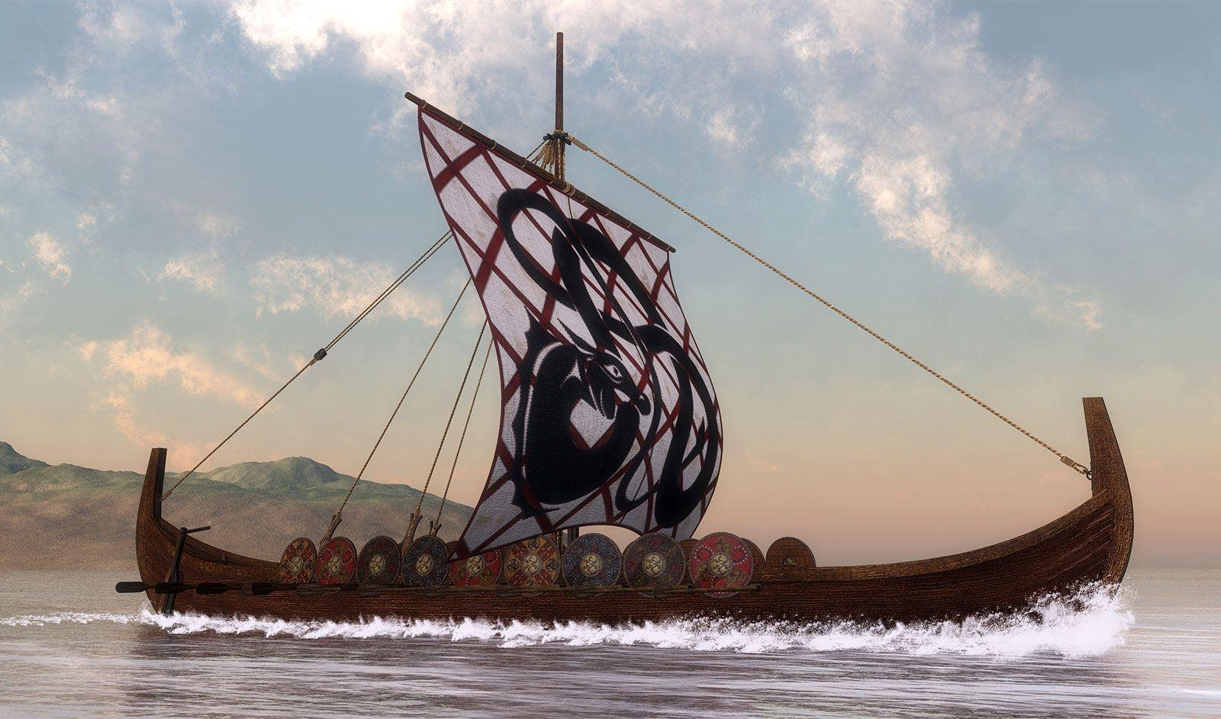

The Wanderer and the Thunder in the City of Steel
Gather close, kin and friends, around these flames that crackle like the old hearths of our ancestors. Let the sparks rise like stars into the night sky, and listen well—I will tell you a tale not from the ancient sagas, but one whispered by the winds of our own time. A story of the gods walking among us, in this age of iron towers and endless lights.
It happened not long ago, in a great city of glass and steel, where rivers of cars flowed like serpents and towers scraped the clouds like the peaks of Jotunheim. In the heart of this Midgard of ours stood an ancient oak tree, alone in a concrete park—an old survivor, its roots twisting deep beneath the streets, its branches reaching toward the polluted sky. Some said it was a child of Yggdrasil itself, hidden here when the world changed.
One stormy evening, as thunder growled low over the rooftops, an old man in a worn gray coat and wide-brimmed hat limped into a crowded subway bar. One eye gleamed sharp beneath the shadow of his hat, the other hidden like a secret. He carried a walking staff carved with runes, and two ravens—black as midnight—perched quietly on his shoulders before flying off into the neon night. Folk called him the Wanderer, though none knew his true name. He sat among the workers and students, buying rounds with coins that seemed older than the city itself, listening to their worries: jobs lost to machines, hearts broken by distance, a world spinning too fast toward chaos.
That same night, across the city, a young electrician named Torvald—broad-shouldered, red-bearded, with a temper as quick as summer lightning—was fixing power lines in the pouring rain. He wore a leather jacket patched with a hammer pendant, a gift from his grandfather. Torvald grumbled at the storm, for it had knocked out lights across half the district, and darker things stirred in the blackout: fear in the streets, opportunists in the shadows, and something older—a growl from beneath the earth, like a giant awakening.
For in the depths below the city, where subways tunneled like the roots of the World Tree, a great serpent of greed had coiled itself around the flow of power. Not Jörmungandr himself, but a shadow of his kin: a force of endless consumption, born from unchecked ambition, sucking energy from the grid, plunging homes into darkness, feeding on the despair it caused.
The Wanderer heard the thunder call and knew the time had come. He left the bar and walked the wet streets until he found Torvald atop his cherry-picker truck, hammer in hand—his tool, but also his weapon.
“Son of thunder,” the old man said, voice steady as stone, “the serpent stirs below. Will you stand as guardian, as your blood once did?”
Torvald laughed at first, thinking the old man mad. But when lightning cracked and illuminated the ravens circling above, he felt the pull in his veins—the old strength rising.
Together they descended into the maintenance tunnels, the Wanderer leading with his staff tapping runes that glowed faintly on the walls. Deep down, where cables twisted like veins, the serpent manifested: a writhing mass of sparking wires and shadowy greed, eyes like flickering screens, fangs dripping outage and ruin.
Torvald raised his hammer—not just the tool, but charged now with the storm’s fury—and called the thunder. Bolt after bolt struck as he swung, shattering the darkness, restoring the flow of light.
The Wanderer watched, offering wisdom in whispers: “Strike true, but know balance—destroy the greed, not the web that connects us all.”
In the end, the serpent was broken, its coils unraveled. Lights flickered back on across the city—homes warmed, streets safe once more. Torvald emerged exhausted but unbroken, and the old man was gone, only a single raven feather left behind.
And so, friends, the gods still walk among us—not in halls of gold, but in subways and storms. The World Tree grows even here, in parks and power lines. When greed coils tight or darkness falls, remember: wisdom wanders, thunder answers the call, and we—mortals with ancient blood—must stand ready.
Raise your cups now, to the old ones who watch, and to the strength within us all.
Thus ends the tale. What say you—does the thunder speak to you tonight?

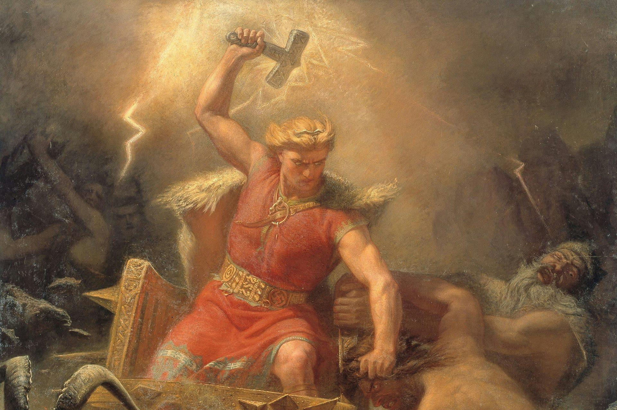

Adapting Viking Principles to Modern Life
This manual provides guidance on incorporating elements inspired by historical Viking society into contemporary living. Historical Vikings (circa 8th–11th centuries) were primarily farmers, traders, explorers, and craftsmen, with a culture emphasizing resilience, community, honor, and connection to nature. Modern adaptations focus on ethical, legal, and practical interpretations, drawing from archaeological evidence, sagas, and contemporary practices such as Heathenry (including Ásatrú). The goal is personal growth, physical vitality, and mindful living, while respecting modern laws and societal norms.
1. Cosmology and Interconnectedness: Yggdrasil in Daily Life and Professional Networks
The World Tree Yggdrasil represents the interconnected Nine Worlds, sustaining life amid constant flux through its vast roots and branches.
1. Mindset and Philosophy
Vikings valued bravery, loyalty, honor, perseverance, and self-reliance, as reflected in sources like the Hávamál (a collection of Old Norse wisdom poetry). In modern terms:
• Cultivate courage by facing challenges directly, whether professional, personal, or physical.
• Embrace a sense of fate with agency: Accept what cannot be controlled, but act decisively within your influence.
• Prioritize honor and integrity: Build a reputation through consistent ethical behavior, generosity, and loyalty to family and friends.
• Foster community: Vikings operated in tight-knit groups. Seek or build supportive networks (“tribes”) through shared interests, such as clubs, sports teams, or volunteer groups.
Modern Heathenry often follows principles like the Nine Noble Virtues (courage, truth, honor, fidelity, discipline, hospitality, self-reliance, industriousness, perseverance) as an ethical framework.
2. Physical Fitness and Training
Vikings were physically robust due to demanding labor and occasional warfare. Adapt this through functional strength training.
• Engage in strength and power exercises: Use bodyweight movements, weightlifting, or “odd object” training (e.g., carrying logs or sandbags) to build resilience.
• Incorporate outdoor activities: Hiking, rowing, swimming in cold water (with safety precautions), or winter sports to mimic environmental hardships.
• Practice martial arts or historical European martial arts (HEMA) focused on Viking-era weapons for discipline and skill, participating in reenactment groups if interested.
• Aim for consistency: Train regularly to develop vitality and mental toughness.
3. Diet and Nutrition
Viking diets were based on available resources: fish, meat, dairy, grains, and foraged foods.
• Focus on whole foods: Emphasize lean proteins (fish, seafood, red meat), vegetables, berries, nuts, and fermented items (e.g., yogurt or sauerkraut).
• Avoid processed foods: Prioritize natural, seasonal ingredients to align with historical self-sufficiency.
• Include traditional elements: Prepare meals like stewed meats, porridge from oats or barley, or smoked fish.
• Practice mindful eating: Meals were communal; share food with others to strengthen bonds.
4. Daily Habits and Lifestyle
Historical daily life centered on farmsteads and seasonal tasks.
• Spend time in nature: Walk, garden, or perform outdoor labor to connect with the environment.
• Develop practical skills: Learn woodworking, forging, knitting, or navigation—skills Vikings valued.
• Maintain hygiene and appearance: Contrary to stereotypes, Vikings prized cleanliness and grooming (e.g., frequent bathing, combing hair).
• Travel and explore: Undertake journeys, even short trips, to experience new places mindfully.
For housing, consider minimalist or eco-friendly living; some replicas exist for inspiration.
5. Spirituality and Community (Optional)
Many modern interpretations include revived Norse paganism (Heathenry or Ásatrú), a recognized religion in several countries.
• Study mythology: Read the Poetic Edda, Prose Edda, or sagas for inspiration.
• Perform rituals: Hold blóts (offerings) with mead or food, focusing on gratitude to deities (e.g., Odin for wisdom, Thor for strength) or ancestors.
• Join communities: Participate in local kindreds or organizations for shared ceremonies, emphasizing inclusivity and rejecting extremism.
• Environmental stewardship: Honor nature spirits through conservation efforts.
Note: Spirituality is personal; not all modern “Viking lifestyle” adherents include religious elements.
6. Considerations and Limitations
• Legal and ethical boundaries: Raiding or violence is illegal and contrary to historical Viking values of honor.
• Balance with modernity: Integrate these practices selectively to enhance life without isolation.
• Health and safety: Consult professionals for fitness, diet, or cold exposure activities.
• Cultural respect: Draw inspiration responsibly, acknowledging that full replication of Viking life is impossible and often romanticized.
By adopting these principles thoughtfully, one can cultivate resilience, purpose, and connection in the present day. This approach honors the enduring legacy of Norse culture while adapting to contemporary realities.
Norse mythology, including key deities, cosmological elements, and runes, as sources of inspiration for contemporary living are aspects, drawn from historical sources such as the Poetic Edda and Prose Edda, provide symbolic frameworks for personal development, ethical reflection, and spiritual practice in modern Heathenry or Ásatrú.

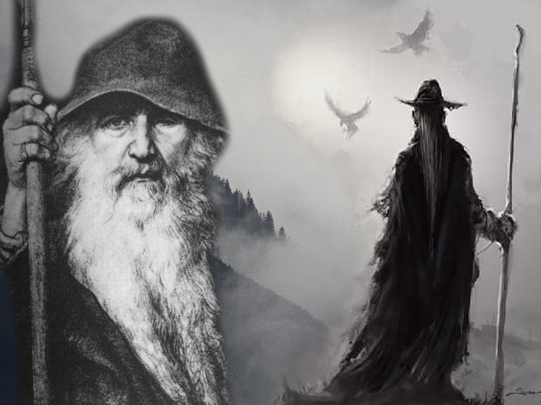

Norse Mythology: Cosmology and the Nine Worlds
Norse cosmology centers on Yggdrasil, the immense World Tree that connects the Nine Worlds, symbolizing interconnectedness and the cycle of existence.
6. The Gods and Goddesses: Inspiration for Modern Virtues
The Norse pantheon divides primarily into the Æsir (associated with war, wisdom, and governance) and Vanir (linked to fertility, nature, and prosperity). Deities embody human-like qualities, offering lessons in resilience amid imperfection.
Major deities and modern applications:
• Odin (Allfather): God of wisdom, poetry, and sacrifice. Invoke for pursuit of knowledge or decision-making.
• Thor: God of thunder, strength, and protection. Symbolizes defense of community; draw upon for physical challenges.
• Freyja: Goddess of love, beauty, magic (seiðr), and war. Represents empowerment and balance; honor in matters of relationships or creativity.
• Freyr: God of fertility, peace, and prosperity. Associated with abundance; reflect on during goal-setting.
• Frigg: Goddess of marriage, foresight, and household. Emphasizes family and intuition.
• Tyr: God of justice and honor. Exemplifies sacrifice for the greater good.
• Loki: Trickster figure of change and chaos. Reminds of adaptability, approached cautiously.
In practice, select a deity aligning with current needs for meditation or offerings (e.g., mead or crafted items), focusing on gratitude and self-reflection.

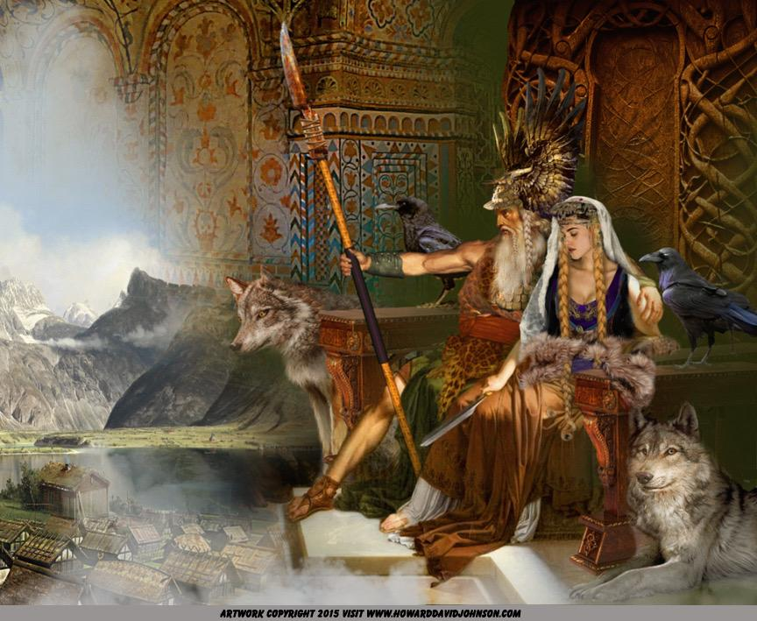

Runes: Symbols of Power and Divination
Runes, particularly the Elder Futhark (24 symbols from the 2nd–8th centuries), served as an alphabet and held mystical significance, attributed to Odin’s self-sacrifice on Yggdrasil.
In contemporary Norse beliefs runes support divination, meditation, or talismans (bindrunes). Approach with study and respect; meanings are interpretive.
Selected Elder Futhark examples:
• Fehu (ᚠ): Wealth, abundance → Focus on prosperity.
• Ansuz (ᚨ): Wisdom, communication → Seek clarity.
• Uruz (ᚢ): Strength, vitality → Build resilience.
• Raidho (ᚱ): Journey, progress → Embrace change.
Craft or study runes mindfully for personal insight.
8. Key Myths and Modern Lessons
Stories from the Eddas convey timeless themes:
• Creation from Ymir’s body: Emphasizes transformation from chaos.
• Ragnarök (doom of the gods): Highlights inevitability of change and renewal.
• Odin’s quest for wisdom: Values knowledge through sacrifice.
• Thor’s battles: Stresses protection and perseverance.
Apply these by reflecting on personal “ragnaröks” as opportunities for growth.
9. Spirituality and Community
(Expanded from previous.) Integrate mythology through study of primary sources, ethical blóts, or community events. Prioritize inclusivity and historical accuracy.
10. Considerations and Limitations
(Previous content remains, with added note: Interpret mythology symbolically to avoid literalism or misuse.)
This enriched approach deepens connection to Norse heritage, promoting purposeful, resilient living in the modern era.
In modern practice, meditate upon Yggdrasil during time in nature to cultivate awareness of interconnectedness and responsibility toward the environment.

6. The Gods and Goddesses: Inspiration for Modern Virtues
The Norse deities are complex figures—flawed, passionate, and profoundly human in their divinity—offering vivid archetypes for personal growth.
• Odin, the one-eyed Allfather, wanders eternally in pursuit of wisdom. In one of his greatest acts of sacrifice, he hung himself from Yggdrasil for nine days and nights, pierced by his own spear, neither eating nor drinking, until the runes revealed themselves to him in a moment of ecstatic vision.
Invoke Odin when seeking deeper understanding or facing difficult decisions.
• Thor, the thunderer, wields his hammer Mjölnir to defend Asgard and Midgard from the chaotic Jötnar (giants), his red-bearded fury shaking the skies as lightning cracks.
Draw upon Thor’s strength for physical trials or the defense of community.
• Freyja, radiant goddess of love, beauty, and war, rides into battle in a chariot drawn by great cats, claiming half the slain warriors for her hall while Odin takes the rest.
Honor Freyja in pursuits of creativity, relationships, or balanced self-expression.
• Loki, the shape-shifting trickster, father of monstrous children—including the wolf Fenrir, the serpent Jörmungandr, and Hel—sows chaos through cunning, yet his actions often propel necessary change.
Reflect on Loki cautiously as a reminder of adaptability amid uncertainty.
Norse myths unfold with dramatic intensity, emphasizing cycles of creation, conflict, and renewal.
• Creation from Ymir: In the primordial void of Ginnungagap, fire and ice met, birthing the frost giant Ymir. The gods Odin, Vili, and Vé slew him, fashioning the world from his body—his flesh became the earth, his blood the seas, his bones the mountains, and his skull the sky.
This myth illustrates transformation emerging from chaos—apply it to personal rebirth after hardship.
• Ragnarök: The prophesied doom arrives in cataclysm: the wolf Fenrir devours Odin, Thor battles the Midgard Serpent to mutual destruction, flames engulf the world, and the gods fall in epic combat against giants and monsters. Yet from the ashes, a renewed earth rises, fertile and inhabited by survivors.
View personal crises as potential “ragnaröks”—moments of destruction leading to growth.
• Odin’s Quest for Wisdom and Thor’s Battles: As described above, these tales underscore sacrifice for knowledge and steadfast.
These enriched, vivid descriptions of Norse myths, supported by artistic representations, aim to deepen inspirational engagement while encouraging symbolic and ethical modern application.
Personal Application: Cultivate mindfulness of interconnections by maintaining work-life balance and nurturing relationships, viewing daily actions as part of a larger ecosystem.

Career and Business:

In networking and team dynamics, treat professional relationships as branches of Yggdrasil—invest in diverse connections across departments or industries for mutual support and opportunity flow. In business strategy, adopt systems thinking to recognize how decisions impact stakeholders, promoting sustainable practices.
Embrace lifelong learning through courses, reading, or mentorship, accepting short-term discomfort for long-term growth.
Career and Business: Prioritize continuous professional development, such as upskilling during market shifts. In leadership, make calculated risks—e.g., reallocating resources or pivoting strategies—viewing temporary setbacks as investments in future success. Use Odin’s foresight for scenario planning in business decisions.
Build physical and mental resilience through consistent training and facing challenges directly.
Career and Business:
Channel Thor’s perseverance in overcoming obstacles, such as competitive pressures or project hurdles. In team leadership, protect and empower colleagues, fostering loyalty. For entrepreneurs, apply this to defending market position through innovation and reliable execution.
Balance ambition with self-care and relationships, embracing creativity in problem-solving.
Career and Business: Leverage emotional intelligence and charisma in negotiations or team motivation. In creative industries or marketing, draw on Freyja’s allure for branding. Promote gender equity and diverse perspectives in business for innovative outcomes.
5. Runes: Tools for Insight and Decision-Making
The Elder Futhark runes, gained through Odin’s sacrifice, offer symbolic guidance.
Use runes for meditation or journaling to gain perspective on choices.
Career and Business:
Employ as a decision-making framework—draw a rune for intuition in uncertainty, or create bindrunes for goals (e.g., combining Fehu for prosperity with Raidho for progress). In branding, incorporate rune aesthetics ethically for authenticity.
View failures as raw material for growth.
Career and Business:
Treat disruptions (e.g., market crashes or company pivots) as opportunities for innovation and reinvention, emerging stronger.
By integrating these Norse elements symbolically and ethically, individuals can enhance personal fulfillment, professional efficacy, and business acumen, cultivating a life of purpose and adaptability in the modern era.
Rune Protection Practices in
Norse-inspired spiritual practices, runes from the Elder Futhark serve as symbolic tools for meditation, talismans, and intentional workings rather than historical “spells” in the Viking era. Protection often employs single runes or bindrunes (combined runes), where symbols overlay to amplify intent.
Key Runes for Protection
• Algiz (ᛉ): Represents divine protection, shielding, and connection to higher guidance. It evokes elk antlers or raised arms in defense.
Thurisaz (ᚦ): Associated with Thor’s hammer, it provides reactive defense, warding off threats like a

Suggested Protection Practices
These modern adaptations emphasize intention. Perform them mindfully, perhaps with an offering (e.g., mead) to deities like Thor or Heimdall.
1. Simple Algiz Shielding
Carve or draw Algiz on paper, wood, or stone. Visualize it as a radiant barrier while stating: “Algiz, guardian rune, shield me from harm and guide my path with strength.” Carry as a talisman or place above doorways.
2. Home Warding Bindrune (Algiz + Thurisaz)
Combine Algiz (shielding) with Thurisaz (defensive force) into a single symbol.
Inscribe on entry points of your home. Intone: “By Algiz and Thurisaz, this space is guarded; harm turns away, strength remains.” Renew periodically.
3. Personal Resilience Talisman (Algiz + Ingwaz ᛜ)
Bind Algiz with Ingwaz (inner potential and peace) for enduring protection.
Wear as jewelry or carry. Affirm: “Algiz shields without, Ingwaz strengthens within; I stand protected and whole.”
4. Defensive Barrier Working (Multiple Algiz)
Draw four Algiz runes facing outward in a square around your space or self. Visualize them as spears of light. State: “Algiz surrounds and protects; no malice shall pass.”
These practices draw from symbolic interpretations and modern Heathen customs, prioritizing personal empowerment and ethical use. Approach with reverence, as runes represent profound
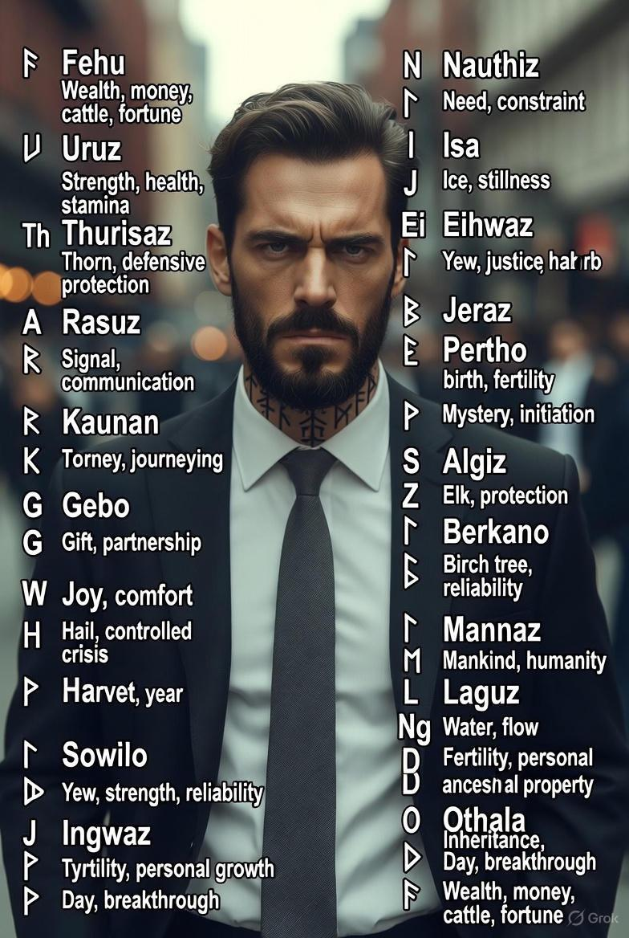
• Fehu (ᚠ): The primary rune of movable wealth, cattle (historical measure of riches), and earned prosperity. It represents new beginnings in abundance and the energy of fruitful exchange.
Jera (ᛃ): Rune of harvest, reward for effort, and cyclical abundance—ideal for long-term prosperity.
• Ingwaz (ᛜ): Associated with fertility, potential, and stored energy leading to growth (linked to the god Freyr).
• Laguz (ᛚ): Flow of wealth, intuition in opportunities, and life force.
• Wunjo (ᚹ): Joy, harmony, and the fulfillment that accompanies prosperity.
Suggested Prosperity Practices
These modern adaptations involve mindful creation of talismans or visualizations. Perform with clear intent, perhaps accompanied by an offering to deities such as Freyr (abundance) or Freyja (prosperity through empowerment).
1. Basic Fehu Activation
Draw or carve Fehu on paper, a coin, or wallet item. Visualize golden energy flowing while stating: “Fehu, rune of wealth earned through honor, bring abundance and opportunity to my path.” Carry daily to attract financial flow.
2. Wealth Attraction Bindrune (Fehu + Jera)
Combine Fehu (initial wealth) with Jera (rewarded harvest) into a unified symbol.
Inscribe on a business card, desk item, or savings container. Affirm: “Fehu ignites wealth; Jera brings the harvest—abundance flows through effort and time.”
3. Comprehensive Prosperity Talisman (Fehu + Ingwaz + Wunjo)
Bind these for wealth, growth, and joyful fulfillment.
Wear as jewelry or place in a workspace. Intone: “Fehu grants wealth, Ingwaz nurtures growth, Wunjo brings joy—prosperity manifests in harmony.”
4. Flow of Opportunity Working (Fehu + Laguz)
Merge Fehu with Laguz for dynamic wealth movement. Visualize as a flowing river of gold. State: “Fehu’s wealth flows freely with Laguz’s current; opportunities arrive effortlessly.”
Approach these practices with reverence and ethical intent, combining them with practical actions such as diligent work or financial planning. Runes amplify focus rather than replace effort.

Use this Viking Journal to help your Journey..
A monthly journal inspired by Norse traditions encourages a lifestyle embodying Viking principles—such as courage, resilience, honor, self-reliance, community, and harmony with nature—while incorporating Elder Futhark runes for personal rituals focused on protection and prosperity.
This modern adaptation draws from historical Norse values and runic symbolism, where runes served alphabetic and potentially symbolic purposes. Practitioners create personal “spells” (galdr or intentions) by drawing bindrunes (combined runes), meditating upon them, or inscribing them during reflection.
The journal structure includes monthly themes aligned with seasonal cycles, a dedicated rune (or pair), a bindrune suggestion, Viking living principles, and space for daily entries
Monthly Structure
Each month features:
• Theme: Seasonal or mythological alignment.
• Focus Rune(s): Selected for protection (e.g., defense, resilience) or prosperity (e.g., wealth, growth).
• Bindrune: A combined symbol to draw/carve for intention-setting.
• Viking Principles: Daily practices (e.g., physical training, honorable actions, nature connection).
• Ritual Suggestion: Meditate on the rune, chant its name, or inscribe the bindrune while stating intentions.
Norse-inspired calendars illustrate seasonal cycles.

January: Renewal and Strength
• Rune: ᚢ Uruz (primal strength, health).
• Bindrune: ᚢ + ᛉ (Uruz + Algiz) for protected vitality.
• Principles: Embrace cold for resilience; train physically; set bold goals.
• Ritual: Draw bindrune on the first page; affirm enduring strength.

February: Protection Against Darkness
• Rune: ᛉ Algiz (protection, shield).
• Bindrune: ᛉ + ᚦ (Algiz + Thurisaz) for defensive force.
• Principles: Honor boundaries; practice mindfulness amid winter.
• Ritual: Inscribe on a personal item for safeguarding.
March: Awakening and Growth
• Rune: ᛒ Berkano (birch, new beginnings, fertility).
• Bindrune: ᛒ + ᛃ (Berkano + Jera) for prosperous growth.
• Principles: Prepare for spring; foster community ties.
• Ritual: Visualize renewal while drawing the bindrune.
April: Journey and Prosperity
• Rune: ᚱ Raidho (journey, rhythm) + ᚠ Fehu (wealth).
• Bindrune: ᚱ + ᚠ for righteous prosperity.
• Principles: Travel or explore; act with honor in endeavors.
• Ritual: Carry the bindrune during new ventures.
May: Vitality and Success
• Rune: ᛊ Sowilo (sun, success).
• Bindrune: ᛊ + ᚷ (Sowilo + Gebo) for balanced success.
• Principles: Celebrate life; engage in outdoor pursuits.
• Ritual: Meditate under sunlight with the rune.
June: Harvest Preparation
• Rune: ᛃ Jera (harvest, reward).
• Bindrune: ᛃ + ᛟ (Jera + Othala) for ancestral prosperity.
• Principles: Work diligently; honor family heritage.
• Ritual: Reflect on efforts yielding future abundance.

July: Endurance
• Rune: ᛇ Eihwaz (yew, reliability).
• Bindrune: ᛇ + ᛉ for enduring protection.
• Principles: Face challenges with steadfastness.
• Ritual: Use during trials for inner strength.
August: Abundance
• Rune: ᚠ Fehu (movable wealth).
• Bindrune: ᚠ + ᛜ (Fehu + Ingwaz) for fertile prosperity.
• Principles: Share bounty; practice generosity.
• Ritual: Inscribe on financial tools.
September: Justice and Balance
• Rune: ᛏ Tiwaz (justice, honor).
• Bindrune: ᛏ + ᚷ for honorable exchanges.
• Principles: Uphold truth; seek equilibrium.
• Ritual: Affirm fair dealings.
October: Transformation
• Rune: ᚺ Hagalaz (hail, disruption leading to change).
• Bindrune: ᚺ + ᛊ for transformative success.
• Principles: Embrace change; prepare for winter.
• Ritual: Release old patterns.

November: Intuition and Flow
• Rune: ᛚ Laguz (water, intuition).
• Bindrune: ᛚ + ᛉ for protected insight.
• Principles: Trust instincts; connect with water elements.
• Ritual: Meditate for Clarity
• Rune: ᛞ Dagaz (day, breakthrough) + ᛟ Othala (ancestral property).
• Bindrune: ᛞ + ᛟ for enlightened stability.
• Principles: Reflect on the year; honor ancestors.
• Ritual: Close the cycle with gratitude.

December: Clarity and Heritage
• Rune: ᛞ Dagaz (day, breakthrough) + ᛟ Othala (ancestral property).
• Bindrune: ᛞ + ᛟ for enlightened stability.
• Principles: Reflect on the year; honor ancestors.
• Ritual: Close the cycle with gratitude.
Examples of bindrunes for protection and prosperity.
This journal promotes disciplined, intentional living rooted in Norse ethos. Adapt entries personally, using runes as focal points for meditation and affirmation

Key Aspects of Norse Romantic Relationships
• Marriage as Alliance with Personal Agency: Marriages were typically negotiated between families, involving a bride-price paid by the groom’s kin and a dowry from the bride’s, securing economic and social ties. However, women possessed significant rights, including the ability to refuse unsuitable matches and initiate divorce on grounds such as abuse, neglect, or poverty. Divorce proceedings allowed women to reclaim their dowry and often a share of joint property, providing financial independence rare in contemporaneous European societies.

Courtship and Expression of Affection:
Courtship involved displays of prowess, generosity, and personal grooming to impress potential partners. Sagas recount passionate affairs, poetic declarations, and devoted partnerships, such as the legendary bond between Ragnar Lothbrok and Lagertha, or the mutual fidelity in tales like Njál’s Saga, where spouses faced fate together.
• Gender Dynamics and Equality: Women managed households, owned property, and held authority in domestic and economic spheres, especially during men’s absences on voyages. This relative equity fostered partnerships based on complementary strengths rather than strict hierarchy.
Adaptations for Contemporary Relationships
Certain Norse principles align with modern values of equity and intentionality, offering practical applications:
• Emphasis on Mutual Consent and Equality: Prioritizing open negotiation and respect for individual agency in partnerships, ensuring both parties contribute to decisions.

Financial Independence and Security:
Encouraging prenuptial agreements or shared financial planning to protect individual assets, echoing dowry reclamation.
• Resilience and Loyalty in Adversity: Cultivating commitment through shared challenges, fostering deep bonds akin to saga depictions of unwavering support.
• Ritual and Intention-Setting: Incorporating symbolic gestures, such as handfasting or exchanges of meaningful tokens, to mark milestones and reinforce partnership.

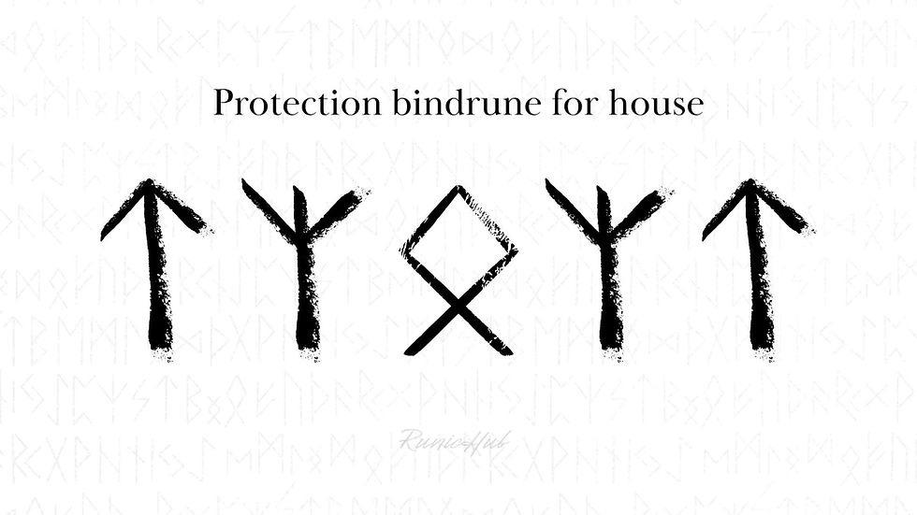

Echoes of Asgard: A Modern Edda
In circuits of steel and neon-lit skies,
Yggdrasil stands, its roots in the cloud,
Branches of fiber optic entwined,
Connecting the worlds where data streams proud.
Odin wanders the digital veil,
One eye on the code, the other on fate,
Ravens of algorithms take flight,
Whispering secrets through servers innate.
Thor strides through the storm of the city at night,
Mjölnir a charger, electric and bright,
Hammering thunder in power grid veins,
Defending the fragile from chaos and strain.
Loki shifts shapes in the viral domain,
Memes and illusions, truth bent into play,
Trickster of firewalls, breaker of chains,
Reminding the mighty that pride leads astray.
Freyja drives swift through the avenues wide,
Cats at her wheels, necklace of light,
Goddess of passion in screens that confide,
Teaching that love endures endless fight.
In boardrooms and streets, the Norns weave their thread,
Fate in the choices of mortals below,
Ragnarok looms in the climate’s red dread,
Yet renewal awaits in the seeds that we sow.
Thus echoes the old in the pulse of the new,
Valhalla a haven for heroes unseen,
In courage and wisdom, the ancient rings true—
The gods walk among us, eternal, serene.
.
