Sovereign Financial Mastery

Overcome Financial Anxiety with a Structured Decision Framework


thesovereignmanprotocol.com

Introduction

The Missing Layer

Before this book, I wrote about systems.

In Bubble Logic, I examined how capital detaches from fundamentals — how narratives inflate valuations, how liquidity distorts discipline, and how intelligent individuals become absorbed into collective overconfidence.

In The Crowd 2.0, I explored digital amplification — how networked psychology accelerates volatility, how online consensus manufactures false certainty, and how algorithmic visibility reshapes risk perception.

In The Sovereign Man Protocol, I turned inward — defining strength, leverage, and structural independence in the age of artificial intelligence.

Each book addressed a layer of the same reality:

Markets are unstable.

Crowds are emotional.

Technology accelerates both.

Yet after years of studying macro systems, digital behaviour, and strategic positioning, one pattern remained persistent — and personal.

Even informed individuals.

Even disciplined allocators.

Even those who understood bubbles and crowd dynamics…

Still woke at 3:17 AM.

Still checked portfolios reflexively.

Still felt the quiet compression in the chest during drawdowns.

Still questioned whether “enough” would remain enough.

Knowledge did not eliminate vigilance.

Understanding volatility did not silence it.

Because the final system had not been addressed.

The internal one.

From External Mastery to Internal Governance

You can understand bubbles and still fear collapse.

You can anticipate crowd psychology and still feel pressure.

You can build income engines and still experience fragility.

Why?

Because financial competence and financial sovereignty are not the same.

Competence manages assets.

Sovereignty governs the internal response to uncertainty.

The modern financial environment intensifies this gap.

Real-time dashboards.

Instant price alerts.

Continuous news cycles.

Algorithmically optimised outrage.

The very tools designed to increase control increase exposure.

Exposure increases vigilance.

Vigilance masquerades as responsibility.

And so the cycle continues.

You optimize the portfolio.

But you do not optimize the nervous system interpreting it.

The Logical Progression of the Sovereign Series

If Bubble Logic examined distortion in markets,

and The Crowd 2.0 examined distortion in collective behaviour,

and The Sovereign Man Protocol examined structural strength in the AI age —

Then Sovereign Financial Mastery addresses the distortion within perception itself.

This is the book about governance.

Not over capital.

Over reaction.

It does not teach you how to allocate.

It teaches you how to remain composed while allocated.

It does not predict markets.

It recalibrates the individual operating within them.

Why This Book Now

We operate in an era defined by:

Accelerated information

Perpetual comparison

Macro instability

AI-driven disruption

Compounded financial visibility

Volatility is no longer episodic.

It is ambient.

The question is no longer:

“How do I build wealth?”

The deeper question is:

“How do I remain psychologically sovereign while managing it?”

Because unmanaged financial vigilance extracts cost:

Reduced strategic clarity.

Compressed decision-making bandwidth.

Subtle relational strain.

Delayed expansion.

Chronic low-grade stress masked as diligence.

This book exists because mastery without composure is incomplete.

What Sovereign Financial Mastery Means

Sovereign Financial Mastery is not about suppressing concern.

It is about structuring it.

It is about converting diffuse anxiety into measurable signal.

It is about pre-defining discretion so decisions no longer require emotional re-litigation.

It is about reducing reactive monitoring and increasing deliberate review.

It is about replacing 3:17 AM vigilance with structured authority.

In previous books, I focused on navigating markets and systems.

Here, we address the operator.

Because the most under-optimized asset in modern finance is not capital.

It is cognition under volatility.

What This Book Is and Is Not

This is not an investment guide.

There are no stock recommendations.

No tactical allocation breakdowns.

No forecasting models.

If you require introductory financial literacy, excellent resources already exist — including works such as The Psychology of Money, which explore behavioural patterns around wealth.

This book assumes you understand the mechanics.

It addresses what remains unresolved after competence.

It delivers a governance protocol.

A structured recalibration.

A repeatable method for establishing internal command over financial uncertainty.

The Evolution

Bubble Logic taught you to see distortion.

The Crowd 2.0 taught you to detach from amplification.

The Sovereign Man Protocol taught you to build structural strength.

Sovereign Financial Mastery teaches you to remain composed while executing all three.

This is not escalation.

It is integration.

Markets will fluctuate.

Crowds will surge.

Technology will accelerate.

Your sovereignty must not.

Chapter 1

The 3:17 Signal

It rarely begins with ignorance.
It begins with competence.
You understand allocation models.
You understand tax efficiency.
You understand liquidity planning, inflation erosion, volatility clustering.
You have done the work.
And yet — at 3:17 AM — you are awake.
The room is dark.
Your partner sleeps undisturbed.
There is no noise.
Except cognition.
At first it feels random. A natural stirring.
Then the thought crystallizes.
The latest drawdown.
Was it within expected deviation?
Has correlation tightened unexpectedly?
Is this transient repricing — or early structural stress?
You reach for the phone.
Biometrics.
Two-factor authentication.
Dashboard.
Red.
Not catastrophic.
Not devastating.
Just enough.
Just enough to activate the internal audit.
Liquidity position in six months.
Trust distributions.
School fee obligations.
Property timing.
Sequence risk.
Geopolitical escalation.
Policy shifts.
AI-driven labor displacement.
You begin recalculating outcomes you have already modelled.
You close the application.
The numbers stop moving.
The mind does not.
Seven minutes pass.
3:24 AM.
Sleep does not return.
This is not panic.
It is vigilance.
And it is far more common among the competent than the careless.

The Competence Paradox
The financially uninformed fear collapse because they lack understanding.
The financially competent fear erosion because they understand too much.
More knowledge increases variable awareness.
More variable awareness increases perceived exposure.
Perceived exposure increases vigilance.
Vigilance disguises itself as responsibility.
You tell yourself:
“I am being prudent.”
But prudence does not require compulsive checking.
Discipline does not require midnight auditing.
The issue is not financial weakness.
It is ungoverned internal surveillance.

The Equation and the Sentinel
Financial education focuses on equations.
Compound returns.
Diversification.
Risk-adjusted performance.
Drawdown tolerance.
The equation is logical.
The sentinel is biological.
The sentinel evolved for threat detection.
It does not calculate Sharpe ratios.
It scans for danger.
A red number is interpreted not as statistical variance —
but as potential instability.
A headline is interpreted not as noise —
but as signal.
A peer’s visible success is interpreted not as context —
but as comparative threat.
The sentinel does not care that you are diversified.
It cares that volatility exists.
And in the modern era, volatility is omnipresent.
Real-time dashboards.
24-hour financial media.
Algorithmically amplified outrage.
Continuous digital comparison.
The environment has become a stimulus engine.
The sentinel has never had more input.

Why Knowledge Is Not Enough
You may have read works like The Psychology of Money.
You understand cognitive bias.
You understand loss aversion.
You understand overconfidence cycles.
Insight is valuable.
But insight does not automatically produce control.
Understanding that humans overreact to loss does not prevent your own internal contraction when the portfolio dips.
Because cognition and reaction are not identical systems.
The equation lives in the prefrontal cortex.
The sentinel lives deeper.
When volatility spikes, biology speaks first.
If there is no structured override, it remains dominant.

The Hidden Cost of Vigilance
Financial vigilance rarely presents as visible distress.
It presents as subtle compression.
Reduced cognitive bandwidth in board meetings.
Micro-tension in conversations about expansion.
Delay in executing bold but rational moves.
Inability to fully disengage on holiday.
A background hum of contingency planning.
You function.
You perform.
But you do not feel entirely free.
And that matters.
Because sovereignty is not merely the accumulation of capital.
It is authority over your internal state while managing it.

The Real Problem
The real problem is not volatility.
Volatility is mathematical.
The problem is undefined thresholds.
When you have not clearly defined:
- What “enough” means
- What level of drawdown is acceptable
- What risks are pre-authorized
- What time horizons are non-negotiable
Every fluctuation feels open-ended.
Open-ended uncertainty activates the sentinel.
The sentinel fills ambiguity with threat.
This is not weakness.
It is design.
But design can be recalibrated.

The First Reframe
The 3:17 Signal is not evidence that you are fragile.
It is evidence that you have built external structure
without fully installing internal governance.
You optimized assets.
You did not yet optimize reaction.
This book exists to close that gap.

The Shift from Monitoring to Governing
Monitoring is reactive.
Governing is predefined.
Monitoring asks:
“What is happening?”
Governing asks:
“Does this violate my established threshold?”
If the answer is no, action is unnecessary.
If the answer is yes, response is structured.
Without predefined thresholds, every fluctuation demands emotional evaluation.
With thresholds, most fluctuations become irrelevant.
Sovereignty is not achieved by eliminating uncertainty.
It is achieved by defining the boundaries within which uncertainty is permitted.

The Commitment
Over the coming chapters, you will:
- Define your Sovereign Standard.
- Establish your Strategic Discretion Threshold.
- Install a daily recalibration protocol.
- Replace compulsive monitoring with structured review.
- Convert anxiety into measurable signal.
The objective is not to suppress vigilance.
It is to repurpose it.
The sentinel remains.
But it no longer commands.
At 3:17 AM, nothing external has changed.
Only governance has.
And when governance is installed, the signal loses authority.
Sleep returns.
We begin.

Chapter 2

The Anxiety Machine
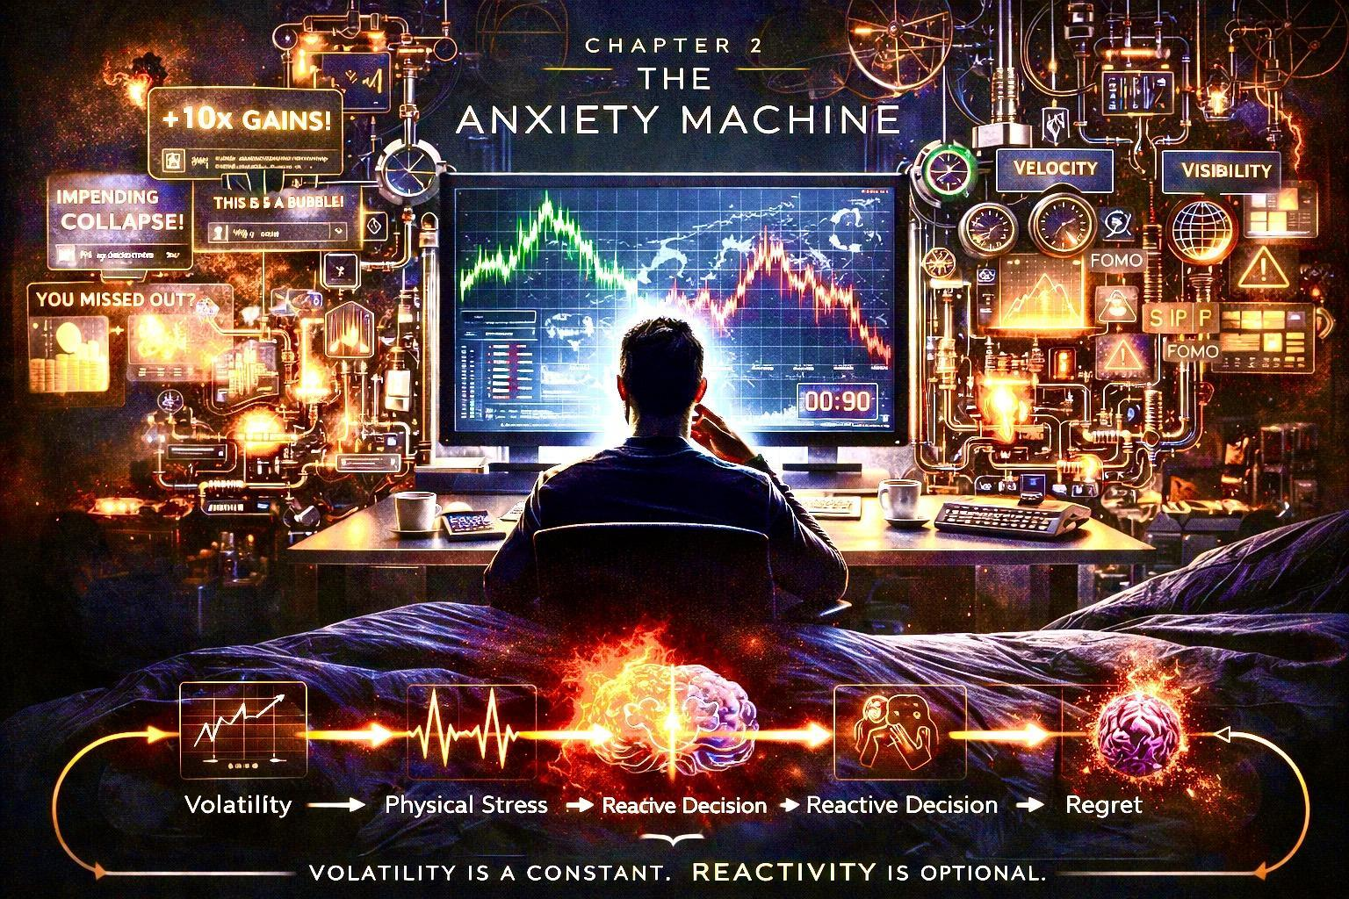
Anxiety around money is rarely about money.
It is about uncertainty.
It is about status.
It is about survival.
It is about control.
And in the modern financial world, all four are constantly under attack.

The Invisible Pressure Field
You wake up and check your phone.
Markets have moved.
News headlines are urgent.
Someone on social media has “10x’d” a position.
Another predicts collapse.
Your nervous system registers all of it as threat.
Not because it understands the data.
But because it interprets volatility as danger.
In Bubble Logic, we explored how distorted narratives inflate risk perception.
In The Crowd 2.0, we dissected how digital mobs amplify emotion.
In The Sovereign Man Protocol, we established personal governance as the antidote to chaos.
Now we go deeper.
Because before you can master money, you must understand the machine that manufactures your stress.

How Financial Anxiety Is Engineered
Modern finance is built on three accelerants:

1. Velocity
Information moves faster than human biology can process.
Your nervous system evolved for:
- Physical threats
- Tribal belonging
- Immediate survival
It did not evolve for:
- 24-hour global trading
- Algorithmic volatility
- Constant portfolio valuation
The result? Chronic stimulation.

2. Visibility
Every gain and loss is now hyper-visible.
Your net worth can fluctuate in real time.
Your peers broadcast wins publicly.
Losses feel private.
Visibility amplifies comparison.
Comparison amplifies insecurity.

3. Narrative Warfare
Every asset class carries competing stories:
- “This is the future.”
- “This is a bubble.”
- “You’re late.”
- “You’re early.”
- “You’re missing out.”
Narrative tension produces cognitive overload.
And cognitive overload produces anxiety.

The Physiological Loop
Financial stress is not abstract.
It is biological.
When you see a sharp market drop:
- Heart rate increases
- Cortisol rises
- Attention narrows
- Impulse control decreases
The body prepares for action.
But there is no tiger.
Only numbers on a screen.
And so the body stays in low-level alert.
This is the Anxiety Machine:
Volatility → Interpretation → Physical stress → Reactive decision → Regret → Reinforced fear.
Left unchecked, it becomes identity.
“I’m bad with money.”
“I can’t handle risk.”
“I always get it wrong.”
But that is not truth.
It is conditioning.

The Sovereign Disruption
The Sovereign does not eliminate volatility.
He eliminates unconscious reaction.
There is a difference.
Most people attempt control through prediction.
The Sovereign builds control through protocol.
Prediction is fragile.
Protocol is stable.
You cannot control markets.
You can control exposure.
You can control position size.
You can control decision timing.
You can control information intake.
Control reduces anxiety.
Clarity replaces fear.

The First Sovereign Shift
Before you change a portfolio, you change a question.
Instead of:
“Will this go up?”
You ask:
“What is my exposure?”
“What is my time horizon?”
“What is my downside defined at?”
“What percentage of my identity is attached to this position?”
The final question is the most important.
Anxiety intensifies when money becomes identity.
When net worth equals self-worth.
When performance equals value.
The Sovereign separates the two.

The 90-Second Rule
When markets spike — up or down — wait 90 seconds before acting.
Not because 90 seconds changes price.
But because 90 seconds changes chemistry.
Your nervous system stabilizes.
Your prefrontal cortex regains influence.
Your decision improves.
This single discipline interrupts the Anxiety Machine.
Small discipline.
Large leverage.

The Reframe
Volatility is not a verdict on you.
It is the cost of participation.
Financial anxiety is not a flaw.
It is an unmanaged signal.
And signals can be governed.
In the next chapter, we move from awareness to structure.
You will design the first layer of Sovereign Financial Architecture — the framework that makes calm the default state rather than the exception.
Because peace with money is not found.
It is built.

Chapter 3

Sentinels and Sovereigns
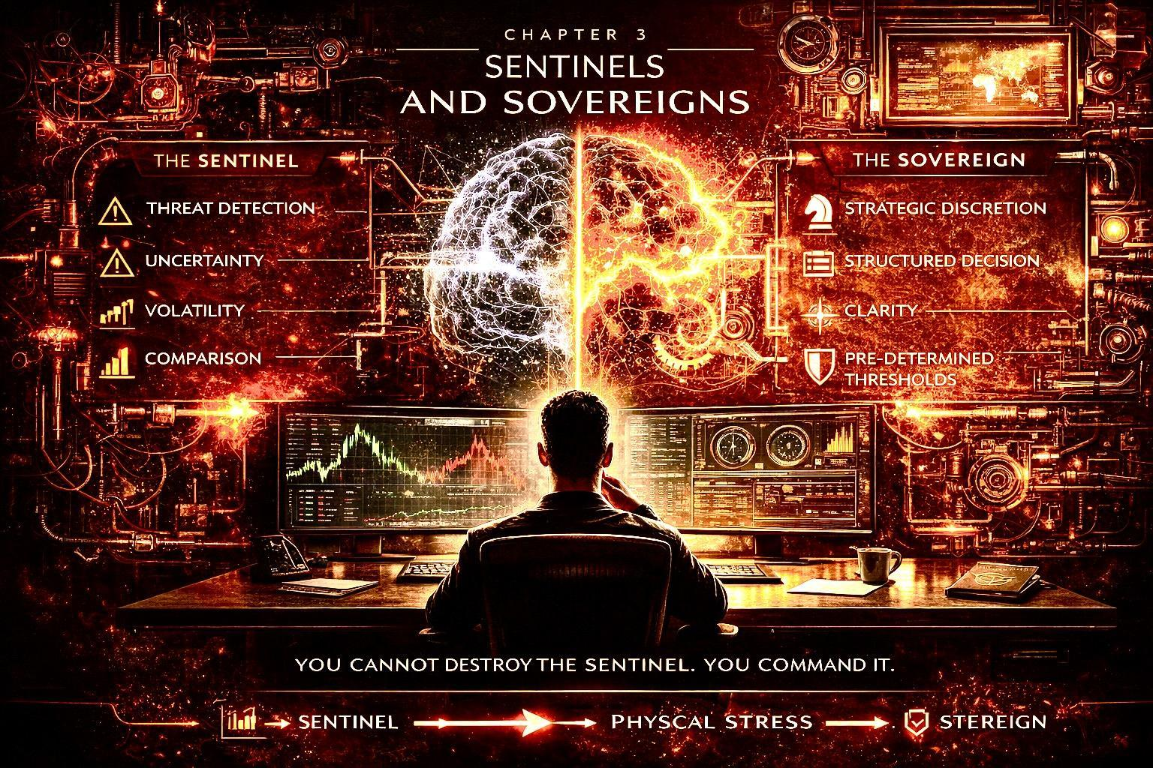
Inside every financial decision, two forces are present.
One reacts.
One governs.
One scans for danger.
One designs for outcome.
You do not eliminate the first.
You command it with the second.

The Sentinel
The Sentinel is ancient.
It evolved to detect:
- Threat
- Scarcity
- Social exclusion
- Loss
In primitive environments, it kept you alive.
In financial markets, it often makes you poor.
The Sentinel does not think in probabilities.
It thinks in absolutes.
“This is dangerous.”
“This is collapsing.”
“This is your last chance.”
It confuses volatility with extinction.
When a position drops 15%, the Sentinel does not see “temporary drawdown.”
It sees:
“You are losing security.”
“You are losing status.”
“You are falling behind.”
And it demands action.
Immediately.

The Modern Amplifier
In earlier decades, the Sentinel activated occasionally.
Now it is triggered daily.
Why?
Because the environment changed.
- Real-time price feeds
- Constant news cycles
- Public performance comparison
- Algorithm-driven emotional headlines
The Sentinel was not designed for permanent stimulation.
So it overfires.
And when it overfires, you override your own plan.
You sell too early.
You buy too late.
You chase noise.
You abandon structure.
Then regret sets in.
Regret strengthens the Sentinel.
The cycle deepens.

The Sovereign
The Sovereign is not emotionless.
He is ordered.
He understands that fear is data — not command.
The Sovereign asks:
- What is the predefined risk?
- What is the time horizon?
- What percentage of capital is exposed?
- What condition invalidates this position?
The Sovereign does not remove uncertainty.
He contains it.
He builds decision architecture that holds under pressure.
Where the Sentinel seeks certainty,
the Sovereign seeks structure.

Command Hierarchy
Most people let the Sentinel outrank the Sovereign.
The emotional impulse becomes the executive authority.
But in a sovereign financial system, the hierarchy is reversed.
Emotion reports.
Protocol decides.
Impulse informs.
Structure executes.
This is governance.
And governance creates peace.

The Stress Threshold
Every investor has a stress threshold.
Cross it — and discipline collapses.
The Sovereign studies this threshold.
Not abstractly.
Quantitatively.
At what percentage drawdown do you lose sleep?
At what volatility level do you check charts compulsively?
At what position size does identity attach?
This is not weakness.
It is intelligence.
You do not build a portfolio around theoretical maximum returns.
You build it around sustainable psychological capacity.
Longevity beats intensity.
Always.

Pre-Commitment Architecture
The Sovereign solves emotional volatility before it arrives.
He defines:
- Entry criteria
- Exit criteria
- Maximum allocation
- Rebalance rules
- Information diet
Before capital is deployed.
When rules are written in calm,
they protect you in chaos.
Without pre-commitment,
every market movement becomes a fresh debate.
And constant debate exhausts the mind.
Exhaustion produces poor decisions.

The Identity Separation
The deepest shift in this chapter is this:
You are not your portfolio.
Your intelligence is not your last trade.
Your worth is not your net worth.
Your competence is not this quarter’s return.
When identity fuses with capital, volatility becomes personal.
When identity is separate, volatility becomes technical.
The Sovereign protects this boundary fiercely.
Because once identity is preserved,
clarity becomes possible.

The Integration
You cannot destroy the Sentinel.
You would not want to.
It protects you from recklessness.
But it must not lead.
The Sentinel detects.
The Sovereign directs.
In the chapters ahead, you will build:
- Structural allocation rules
- Exposure limits aligned with psychology
- Decision frameworks that remove urgency
- Information boundaries that reduce noise
This is not about outperforming markets.
It is about outperforming your own impulses.
Because once internal volatility is reduced,
external volatility loses its power.
And that is the beginning of Sovereign Financial Mastery.

Chapter 4

The Architecture of Calm


Anxiety is not eliminated by motivation.
It is eliminated by design.
You do not “try” to be calm in markets.
You construct conditions where calm becomes the default setting.
This is where Sovereign Financial Mastery shifts from psychology to engineering.

From Emotion to Architecture
Most people approach money emotionally first and structurally second.
They:
- React to opportunity
- React to fear
- React to comparison
Structure is added afterward — usually after pain.
The Sovereign reverses this.
Structure comes first.
Emotion adapts to structure.
When architecture is clear, uncertainty shrinks.
Not because the world is safer.
But because your exposure is defined.

Layer One: The Stability Base
Every Sovereign portfolio begins with a Stability Base.
This is not exciting capital.
It is calming capital.
Its purpose is not maximum growth.
Its purpose is psychological insulation.
The Stability Base answers one question:
“If everything volatile dropped tomorrow, would I still be secure?”
If the answer is no, anxiety will always override discipline.
The Stability Base may include:
- Cash reserves
- Low-volatility assets
- Income-generating positions
- Capital with defined downside
The exact composition varies.
The function does not.
It reduces existential fear.
And existential fear is the root of financial stress.

Layer Two: The Strategic Engine
Above stability sits growth.
This is where ambition lives.
This is where asymmetry is pursued.
But it operates within predefined limits.
The Sovereign does not allocate randomly.
He defines:
- Maximum percentage per position
- Maximum exposure per asset class
- Maximum correlation overlap
Growth without containment breeds instability.
Contained growth produces confidence.
When you know the worst-case scenario in advance,
your nervous system remains regulated.

Layer Three: The Optionality Layer
Optionality is controlled speculation.
This is the arena for:
- High-risk asymmetric bets
- Emerging trends
- Experimental theses
But here is the rule:
If it went to zero, your life would not change.
This is critical.
Most anxiety does not come from risk.
It comes from overexposure to risk.
Optionality is powerful — when small.
Dangerous — when oversized.
The Sovereign keeps it proportionate.

The Information Diet
Architecture is not only financial.
It is informational.
Your mind consumes headlines like your body consumes food.
Poor diet → inflammation.
Poor information → agitation.
The Sovereign restricts:
- Frequency of portfolio checks
- Sources of financial commentary
- Exposure to performative success narratives
You do not need constant stimulation to be informed.
You need clarity, not noise.
When information flow slows, stress falls.

Decision Windows
Reactive investors operate continuously.
Sovereign investors operate in windows.
For example:
- Portfolio review: once per week
- Allocation adjustment: once per month
- Thesis reassessment: quarterly
Outside these windows, no action.
This single discipline reduces impulsive behavior dramatically.
It creates distance between stimulus and response.
Distance creates power.

The Calm Equation
Calm is not personality-based.
It is mathematical.
Calm = Defined downside + Controlled exposure + Structured review cycles
Remove one element, anxiety returns.
Add all three, stability emerges.
You are not seeking perfection.
You are seeking sustainability.

The Long Game Advantage
Here is the paradox:
The calmer investor often outperforms the anxious one.
Why?
Because:
- He avoids panic selling
- He avoids euphoric overbuying
- He compounds consistently
- He preserves capital during chaos
Emotional volatility destroys compounding.
Calm protects it.
And compounding, protected over decades, becomes dominance.

The Shift
You are no longer attempting to “handle stress.”
You are designing a system that reduces the conditions that create it.
That is sovereignty.
In Chapter 5, we move from structure to identity — because even the strongest architecture fails if the operator lacks internal alignment.
Financial mastery is not just portfolio design.
It is self-governance.

Chapter 5

Strategic Discretion: Commanding Decisions Under Pressure
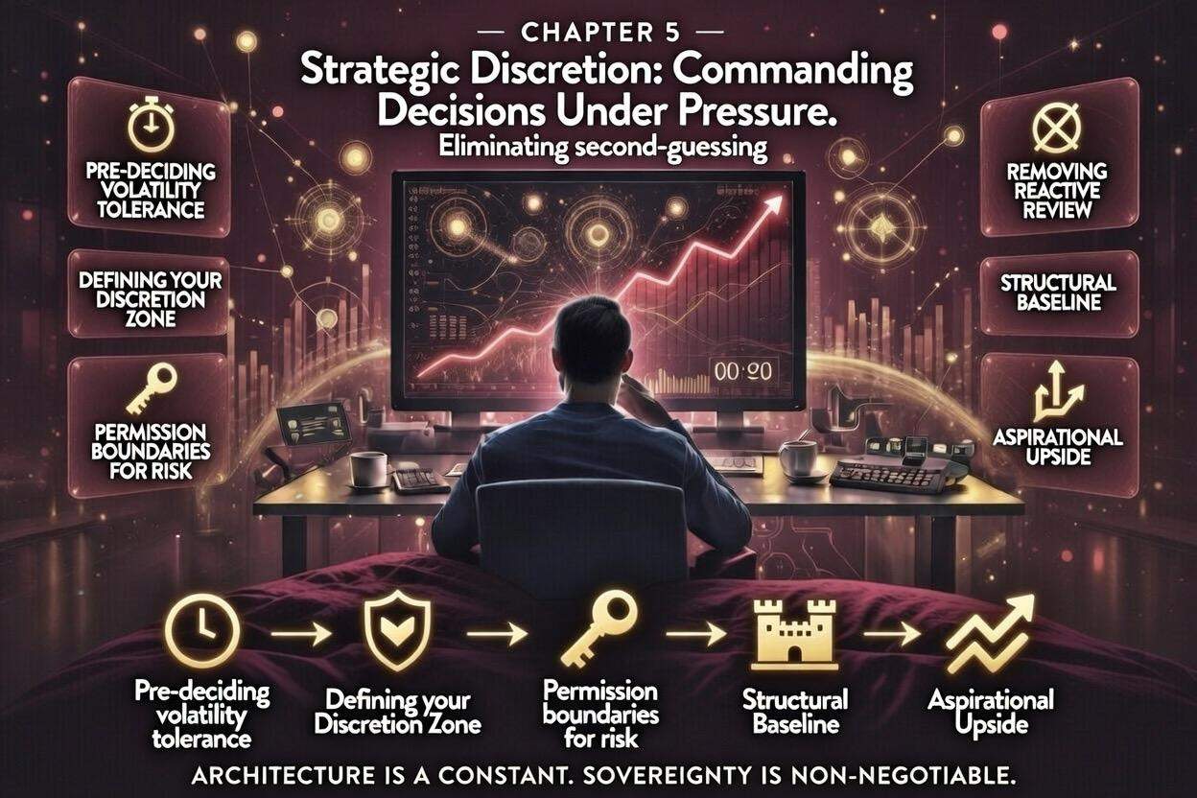
Sovereignty is not about avoiding risk.
It is about deciding in advance what risks are acceptable, what outcomes are tolerable, and what actions are allowed under any circumstance.
This is the core principle of Strategic Discretion. It is the difference between reactive vigilance and deliberate command.

The Anatomy of a Discretion Zone
Your Discretion Zone is your mental and operational territory. Within it, you act freely. Outside it, you do nothing.
It has four dimensions:
- Exposure Limits – maximum allocation to any single asset, thesis, or sector.
- Volatility Tolerance – the threshold of price movement that will not trigger an emotional response.
- Identity Separation – the clear boundary between your self-worth and your portfolio performance.
- Decision Windows – pre-defined periods when evaluation and adjustment are permitted, and when all monitoring is paused.
Example:
- Exposure Limit: No more than 8% of liquid capital in a single high-volatility asset.
- Volatility Tolerance: Do not react to daily swings under 3%.
- Decision Windows: Portfolio review only on Monday mornings; adjustments quarterly.
This system transforms impulsive reactions into pre-approved, emotionally neutral operations.

Pre-Commitment: The Sovereign’s Shield
The most common error high achievers make is reactive overreach.
- The Sentinel triggers.
- Anxiety rises.
- Action occurs outside pre-planned strategy.
- Regret follows.
Pre-commitment eliminates this.
Principles of Pre-Commitment:
- Write Everything Down: Every asset, threshold, and scenario is documented.
- Define Triggers, Not Targets: Focus on conditions that require action, not predicted outcomes.
- Enforce Discipline Mechanically: Use checklists, dashboards, or automated alerts.
- Audit Your Decisions: Monthly review to ensure thresholds are respected.
The goal is not rigidity; it is mechanical control over response, ensuring you act only when structure demands.

Daily Recalibration: Your Five-Minute Sovereign Window
Strategic Discretion is reinforced daily.
Each morning, spend five minutes on targeted recalibration:
- Confirm Exposure Compliance: Are all positions within Discretion Zone limits?
- Identify Trigger Breaches: Any positions exceeding volatility tolerance or predefined risk thresholds?
- Check Emotional State: Am I feeling pressure from news, peers, or social comparison?
- Review Pre-Approved Responses: Does action align with the documented protocol?
- Adjust Only When Necessary: If no thresholds are breached, do nothing.
This brief daily habit transforms constant reactivity into confident stillness, even when markets scream.

The Confidence Multiplier
Strategic Discretion does more than reduce stress. It multiplies confidence exponentially.
Why?
- Decisions are pre-validated.
- Emotional impulses are neutralized.
- Cognitive bandwidth is freed for strategy, not micro-management.
- You operate from principle, not panic.
When the market drops 7%, you do not question your judgment. You observe and execute only within your structure. Confidence becomes predictable and self-reinforcing, rather than sporadic and reactive.

Scenario Planning and Sentinel Management
Strategic Discretion is not theoretical; it thrives on scenario planning.
Ask:
- “What is the absolute worst-case outcome in this asset class?”
- “At what point do I intervene?”
- “What sequence of events would force me to violate my Discretion Zone?”
For each scenario, document exact action plans.
Sentinel Management: The Sentinel will react anyway. That is its function. Your goal is to translate emotional signals into measured data:
- Heart rate spikes → check thresholds.
- Red volatility alerts → compare to predefined tolerance.
- News panic → consult only within protocol.
The Sentinel remains active. But it no longer commands.

Identity Separation: The Deep Anchor
The single most dangerous source of financial anxiety is identity fusion:
- Portfolio value = Self-worth
- Performance = Personal competence
Strategic Discretion requires absolute separation.
- Name your exposure as capital, not identity.
- Label decisions as tactical, not moral.
- Celebrate execution, not outcome.
When identity is separate, fear does not hijack decisions. Stress becomes signal, not sabotage.

The Three Rules of Strategic Discretion
- Boundaries First – Never act outside pre-defined limits.
- Protocol Always – All actions follow documented thresholds.
- Identity Protected – Decisions are structural, not personal.
Consistency with these rules turns vigilance into controlled monitoring and panic into deliberate pause.

Multi-Layer Integration
Strategic Discretion does not stand alone:
- Chapter 2 (Anxiety Machine): Converts recognition of stress into actionable thresholds.
- Chapter 3 (Sentinel): Channels emotional responses rather than suppressing them.
- Chapter 4 (Architecture of Calm): Applies thresholds to structural layers for sustainable execution.
Without Strategic Discretion, architecture is inert. Vigilance dominates. Emotional overreaction dictates outcomes.
With it, every system — biological, financial, and cognitive — functions in alignment.

Sovereign Exercise: Define Your First Discretion Zone
- List every significant position and asset class.
- Define maximum exposure per position.
- Set volatility tolerance levels.
- Establish decision windows for monitoring and action.
- Note potential triggers and pre-approved responses.
This becomes your first operational protocol. Review daily, enforce weekly, and audit monthly.
Strategic Discretion transforms you from a reactive observer of chaos into an architect of controlled outcomes.

Chapter 6

The Daily Sovereign Protocol
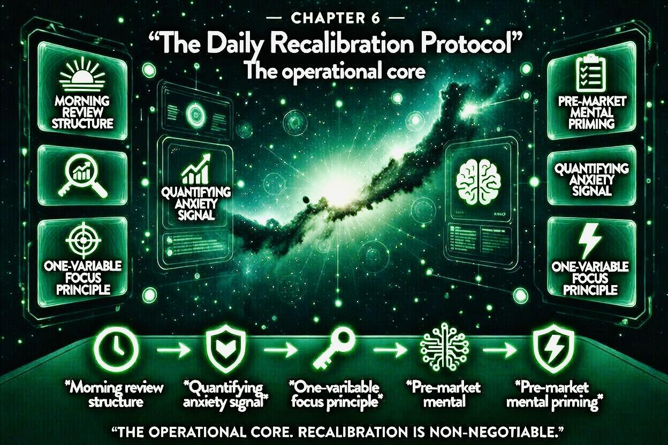

Up to this point, we have established the foundation:
- Chapter 2: Recognized the Anxiety Machine
- Chapter 3: Learned the Sentinel vs. Sovereign distinction
- Chapter 4: Built the Architecture of Calm
- Chapter 5: Defined Strategic Discretion
Now it is time to operationalize everything.
The Daily Sovereign Protocol transforms concepts into habitual action. It is the engine that converts knowledge into internalized calm and consistent decision-making.

The Philosophy of Daily Sovereignty
The Daily Sovereign Protocol is built on three principles:
- Short and Repeatable: A protocol must be sustainable. If it takes more than 15 minutes, it will fail under pressure.
- Non-Reactive: The protocol is executed regardless of market mood, news, or peer behavior.
- Feedback-Oriented: Each day’s practice provides data for continuous refinement.
The goal is cognitive autopilot under volatility. When external stimuli spike, internal governance remains stable.

Step 1: Morning Recalibration (5 Minutes)
Before opening screens or apps:
- Check Exposure: Are all positions within Discretion Zone limits?
- Review Triggers: Any assets exceeding volatility thresholds?
- Emotional Check: What is my current state? Calm, anxious, or reactive?
- Affirm Boundaries: Repeat silently: “I act only within my thresholds. Everything else is observation.”
- Plan the Day: Identify critical tasks beyond financial monitoring.
Effect: Your nervous system begins the day in structure mode, not reaction mode.

Step 2: Information Discipline (Variable)
- Limit active market monitoring to pre-defined windows (e.g., 10–15 minutes per day).
- Subscribe only to high-quality, concise updates.
- Avoid performative commentary, social comparison, and sensationalist media.
Principle: Information is fuel for execution, not stimulus for anxiety.

Step 3: Micro-Check-In (2–3 Minutes, Optional)
If stress arises during the day:
- Pause. Close screens.
- Ask: “Has any position crossed my threshold?”
- Confirm: Yes → follow pre-approved action. No → return to planned activity.
- Log observation if desired.
Effect: You prevent the Sentinel from hijacking your executive function.

Step 4: Decision Window Execution (Pre-Scheduled)
Once per week or month (depending on protocol):
- Review positions in line with Strategic Discretion.
- Rebalance only if thresholds dictate.
- Record rationale, decisions, and emotions.
Effect: Decisions become deliberate, traceable, and unemotional.

Step 5: Evening Reflection (5 Minutes)
At day’s end:
- Note deviations from the protocol. Were any thresholds breached? Why?
- Evaluate emotional state. Was the Sentinel triggered unnecessarily?
- Document lessons learned.
- Affirm commitment: “Today I acted within structure. Tomorrow I continue.”
Effect: Reinforces sovereignty, turning awareness into habit.

The Protocol in Action: Case Study
Scenario: Market drops 6% in one morning.
- Reactive Mind: Panics → reviews positions compulsively → may sell impulsively → regret → anxiety continues.
- Sovereign Protocol:
  - Morning Recalibration confirms exposures within limits.
  - No trigger is breached.
  - Decision windows dictate monitoring only.
  - Micro-Check-In ensures Sentinel remains informative, not commanding.
  - Evening Reflection confirms no unnecessary action, confidence reinforced.
Outcome: Capital preserved. Cognitive bandwidth maintained. Sleep unaffected.

Integration With Architecture
The Daily Sovereign Protocol links all prior chapters:
- Architecture of Calm: The Stability Base, Strategic Engine, and Optionality Layer are maintained without emotional interference.
- Strategic Discretion: Thresholds guide decisions automatically.
- Sentinel Awareness: Emotional signals are monitored, quantified, and managed.
This creates compound calm: the longer the protocol is followed, the more resilient the nervous system becomes.

Optional Enhancements
For high-frequency operators:
- Automate alerts for threshold breaches.
- Maintain a daily log for week-over-week reflection.
- Visual dashboards for rapid assessment.
Automation supports the protocol but does not replace cognitive sovereignty.

The 30-Day Integration Plan
- Week 1: Morning Recalibration & Information Discipline
- Week 2: Add Micro-Check-In
- Week 3: Execute Decision Windows faithfully
- Week 4: Evening Reflection & protocol refinement
After 30 days, the operator will notice:
- Reduced anxiety
- More consistent decision-making
- Less reactive behavior
- A measurable sense of internal sovereignty

Closing Principle
Sovereignty is not earned through knowledge alone.
It is earned by daily practice, disciplined structure, and pre-commitment.
The 3:17 AM signal will eventually appear.
You will notice it.
You will observe it.
And nothing will need to be done outside the protocol.
You are no longer reacting to markets.
You are commanding your mind while markets move.
This is the essence of Sovereign Financial Mastery.

Chapter 7

Operating During Market Stress: When the Red Numbers Expand
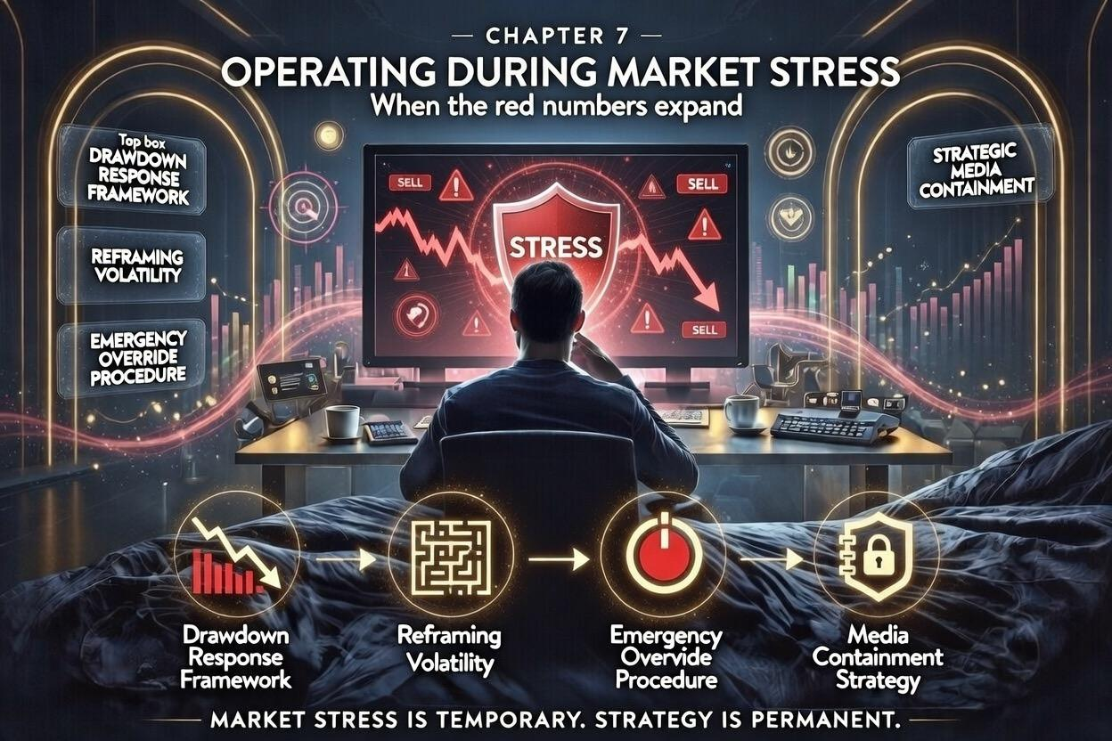
The true test of a Sovereign is not calm during quiet markets, but composure during the storm.
When the red numbers expand, the market is not just signaling price movement. It is signaling opportunity, danger, and, most importantly, your internal state.
This chapter provides the advanced framework for navigating drawdowns, reframing volatility, overriding impulsive responses, and containing external noise — the four pillars of operational mastery under stress.

The Drawdown Response Framework
A drawdown is inevitable. Every portfolio will experience temporary declines. The question is how you respond.
Step 1: Quantify the Drawdown
- Measure absolute and percentage loss relative to the portfolio and each layer of your architecture: Stability Base, Strategic Engine, Optionality Layer.
- Compare to your pre-defined Volatility Tolerance.
Step 2: Categorize the Event
- Minor Drawdown: Below tolerance thresholds. Observe, do not act.
- Moderate Drawdown: Approaching upper tolerance limits. Prepare, but maintain structure.
- Severe Drawdown: Exceeds thresholds. Initiate pre-approved emergency protocol.
Step 3: Execute the Response
- Minor: No action. Maintain discipline.
- Moderate: Review Strategic Engine, optional rebalancing if necessary. Avoid emotional trades.
- Severe: Follow Emergency Override Procedure (see below).
Step 4: Record and Analyze
- Maintain a log of triggers, emotional state, and actions.
- Reinforces learning and strengthens the Sentinel without ceding authority.
The goal is to operate with clarity rather than reaction, regardless of red numbers.

Reframing Volatility
Volatility is not inherently negative. It is the raw material for opportunity.
The Sovereign Reframe:
- Volatility signals price discovery, not moral judgment.
- Temporary declines are information, not catastrophe.
- Red numbers indicate potential asymmetric entry points, not threats to identity.
- Emotional response is data, not command.
Practical application:
- When a drop occurs, pause. Ask: “Does this breach any thresholds?”
- If not, treat the move as neutral information.
- If yes, act mechanically according to protocol.
Reframing volatility neutralizes fear, allowing rational assessment instead of impulsive action.

Emergency Override Procedure
Even the most disciplined protocols require an emergency override.
Step 1: Identify Breach
- Has the portfolio exceeded defined drawdown tolerance?
- Are multiple positions simultaneously outside safe ranges?
- Are external conditions threatening structural integrity of the plan?
Step 2: Execute Pre-Defined Actions
- Move assets from Optionality Layer to Stability Base if necessary.
- Temporarily halt new exposure.
- Activate communication plan with advisors if appropriate.
Step 3: Isolate Emotion
- Suspend social media, news, and speculative chatter.
- Record emotional state in log before making adjustments.
- Validate that action aligns with pre-committed rules, not impulse.
Step 4: Confirm Sovereign Control
- Reassess whether thresholds are reset and understood.
- Re-enter standard daily protocol after stabilization.
Emergency Override is not panic. It is pre-calculated intervention. The Sentinel may flare, but governance remains in control.

Media Containment Strategy
Information overload is one of the most insidious amplifiers of financial stress.
Principles:
- Pre-Define Sources – Only track updates from high-quality, reliable outlets. Eliminate performative and speculative media.
- Time-Box Consumption – Limit exposure to short, scheduled windows. No constant feeds.
- Contextualize Headlines – Red numbers are relative, not absolute.
- Filter Opinion – Avoid commentary-driven panic; focus on actionable metrics.
Implementation:
- Mute notifications during active market hours.
- Review only during daily or weekly protocol windows.
- Treat social media as entertainment, not intelligence.
The objective is reducing noise while maintaining essential awareness, ensuring the Sentinel informs but does not hijack behavior.

Anchoring Decisions Under Stress
Key principles to internalize:
- Structure Over Emotion: Follow the architecture and thresholds. Never improvise under duress.
- Threshold Discipline: Treat breaches as signals, not triggers for instinctive reaction.
- Identity Separation: Do not let temporary losses redefine self-worth.
- Feedback Loops: Use every drawdown as a learning opportunity; reinforce the protocol, not exceptions.
The difference between reactive and sovereign operators is pre-defined control. Markets may panic, headlines may scream, red numbers may expand — but the Sovereign observes, executes, and maintains calm.

Practical Exercise: Stress Drill
- Simulate a 10% drawdown across your Strategic Engine.
- Execute the Drawdown Response Framework.
- Activate Emergency Override if thresholds breached.
- Record emotional state, decisions made, and lessons learned.
- Reframe the volatility: identify opportunities and confirm adherence to identity separation.
- Repeat monthly or quarterly to condition mental response.
Over time, red numbers no longer provoke panic. They provoke measured action and reinforced calm.

Closing Insight
Stressful markets reveal the strength of your internal architecture, not your external strategy.
The Sovereign does not ignore red numbers. He observes, interprets, and acts only where protocol permits.
Markets are unpredictable. Human emotion is predictable. Master the latter, and the former becomes manageable.
**Operating during market stress is not luck. It is practice, discipline, and pre-committed governance.

Chapter 8

Social Comparison Immunity: Neutralizing Peer Pressure
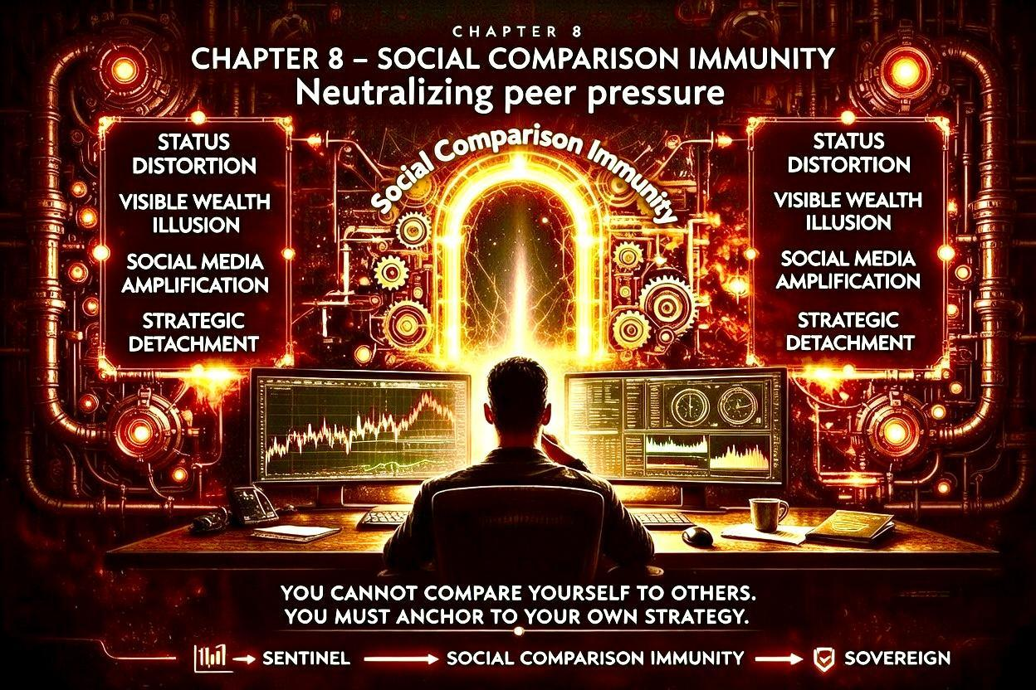
Financial mastery is not only about markets, risk, and structure. It is also about the social ecosystem in which your wealth and decisions exist.
Even the most disciplined portfolio can be undermined by peer pressure, status distortion, and the constant performance parade of modern life.
Chapter 8 provides the framework for developing immunity to social comparison, neutralizing peer influence, and maintaining sovereign decision-making.

Status Distortion: The Hidden Pressure
Human brains are wired to evaluate social standing. Status influences emotion, perception, and decisions more than abstract logic.
In finance, this manifests as:
- Buying assets because peers have them.
- Selling out of fear of being “left behind.”
- Chasing returns for approval, not strategic alignment.
The Sovereign Reframe:
- Recognize status as a signal, not a mandate.
- Understand that perceived superiority or inferiority is often arbitrary and transient.
- Treat status signals as noise, not guidance.
By exposing status distortion, you begin to separate influence from instruction.

The Visible Wealth Illusion
In the age of social media, wealth is performative.
- Luxury lifestyles, high-profile trades, and headline-worthy deals are displayed constantly.
- The visible wealth of others distorts perception of risk, reward, and timing.
- It amplifies the fear of missing out (FOMO) and triggers impulsive decisions.
Sovereign Principle:
- Internalize the reality: what is seen is curated, not complete.
- Measure your performance against your own pre-defined architecture, not the public display of others.
- Focus on long-term compounding and sustainability, not short-term spectacle.

Social Media Amplification
Social media is the modern megaphone of comparison. It magnifies success, masks context, and heightens anxiety.
Effects:
- Red numbers in the market feel worse when peers appear unaffected.
- Gains by others induce envy, even if irrelevant to your strategy.
- Viral investment advice creates pressure to act without protocol.
Strategic Detachment from Media:
- Time-Box Interaction: Limit exposure to specific windows.
- Filter Quality: Follow only trusted sources, remove commentary-driven feeds.
- Signal vs. Noise: Ask, “Does this information require a structural response, or is it just emotion?”
Detachment does not mean ignorance. It means intentional engagement, not reactive consumption.

Neutralizing Peer Pressure
Peer pressure is subtle, continuous, and powerful. It operates even in professional, high-net-worth circles:
- Boardroom narratives about “the right play”
- Friends comparing returns casually
- Advisors referencing “market norms”
Sovereign Tools to Neutralize:
- Protocol Anchoring: All decisions are validated against pre-defined thresholds, not peer behavior.
- Private Benchmarks: Evaluate performance using internal metrics, not external comparisons.
- Reflection Discipline: Pause before reacting to social influence; identify whether action aligns with Strategic Discretion.
- Peer Awareness: Acknowledge influence exists but do not allow it to dictate action.
Over time, your attention shifts from external validation to internal governance.

Strategic Detachment
True sovereignty is cultivated through strategic detachment.
- Actively define what stimuli are meaningful and which are distractions.
- Separate observation from participation. Seeing others succeed does not necessitate imitation.
- Build rituals that reinforce independence from social performance metrics.
Daily Exercise:
- List recent instances where peer activity influenced thoughts or stress.
- Compare those impulses to your protocol: were they actionable, or noise?
- Reaffirm boundaries: decisions occur only within your architecture and thresholds.

Anchoring Identity Outside Comparison
The deepest protection against social pressure is anchoring identity externally from wealth:
- Your value is not portfolio size.
- Your competence is not your latest gain.
- Your self-worth is not benchmarked to anyone else.
Sovereigns operate from clarity of self, not public perception.

Integration With Previous Chapters
Social Comparison Immunity supports all prior layers of Sovereign Financial Mastery:
- Sentinel management (Ch. 3): Prevents emotional hijack from social signals.
- Architecture of Calm (Ch. 4): Reduces stress magnification from peer influence.
- Strategic Discretion (Ch. 5): Ensures decisions are protocol-driven, not peer-driven.
- Daily Sovereign Protocol (Ch. 6): Daily practice reinforces boundaries against social pressure.
- Operating During Stress (Ch. 7): Reduces compounding stress from social amplification during drawdowns.
By cultivating immunity, the Sovereign protects cognitive bandwidth, emotional balance, and consistent execution.

Closing Principle
Wealth is as much a social phenomenon as a financial one.
Red numbers and market volatility are external.
Peer pressure and performative wealth are internal threats.
The Sovereign neutralizes both:
- Observes markets, protocols, and social cues.
- Acts only where thresholds dictate.
- Preserves identity, focus, and composure.
This is Social Comparison Immunity — the final defense layer for sustainable, sovereign financial mastery.

Chapter 9

Expansion Without Anxiety: Scaling Capital Calmly
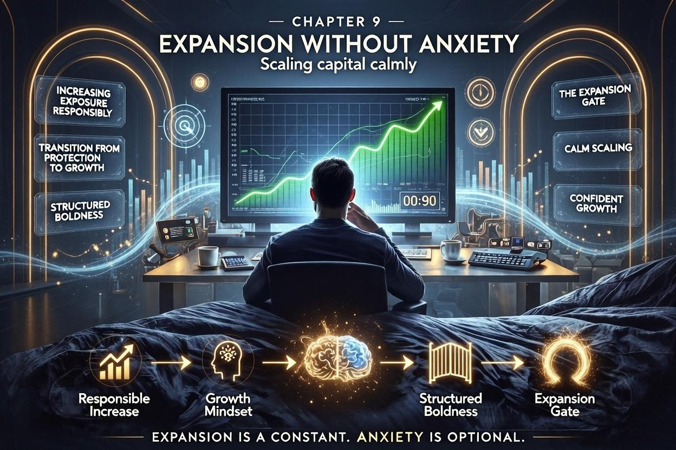
Financial sovereignty is not static. It is growth under control.
The challenge for high-functioning investors is this: once the foundational architecture is secure, the portfolio is calm, and the Sentinel is managed, how do you expand without triggering anxiety?
Chapter 9 provides an in-depth framework for scaling capital calmly, increasing exposure responsibly, and transitioning from a protective mindset to one of structured boldness.

The Expansion Mindset
Many investors reach a point where their Stability Base, Strategic Engine, and Optionality Layer are optimized. Performance is consistent. Stress is contained.
At this stage, opportunity often meets hesitation:
- Fear of overexposure
- Fear of disrupting equilibrium
- Fear of the unknown
The Sovereign recognizes this fear as a signal, not a barrier. Expansion is possible — but only within controlled thresholds.
Principle: Expansion without a plan is reckless. Expansion with governance is opportunity.

Increasing Exposure Responsibly
Scaling capital is not about chasing returns. It is about incremental, measured growth.
Step 1: Define Exposure Layers
- Each new allocation should have its own threshold within the architecture.
- Never exceed a pre-defined percentage of total capital per new position or strategy.
Step 2: Stress-Test the Expansion
- Simulate potential drawdowns of new exposures.
- Confirm that stress remains within your emotional tolerance.
Step 3: Confirm Alignment With Strategic Discretion
- Expansion decisions are reviewed using existing protocol thresholds.
- The Sentinel signals but does not override pre-approved decisions.
Result: Growth is aggressive in opportunity, defensive in structure.

Transitioning From Protection Mindset to Growth Mindset
Protection-focused investors often:
- Emphasize downside avoidance
- Prioritize the Stability Base above all
- Hesitate to allocate to growth opportunities
Sovereigns evolve from risk-avoidant to growth-aware:
- Anchor in Protection: Keep the Stability Base intact.
- Gradual Scaling: Expand the Strategic Engine and Optionality Layer methodically.
- Psychological Readiness: Practice exposure in small, controlled increments.
- Normalize Volatility: Accept that temporary drawdowns are part of growth, not threats to identity.
Key Insight: Growth is only sustainable when psychological capacity matches capital capacity.

Structured Boldness
Bold moves are not reckless. They are calculated, pre-committed, and disciplined.
Elements of Structured Boldness:
- Opportunity Identification: Only act when a favorable asymmetry exists.
- Controlled Size: Risk exposure is limited relative to the total portfolio.
- Pre-Approved Protocol: Every bold allocation has an entry, exit, and contingency plan documented.
- Mindful Monitoring: Use scheduled review windows to observe, not obsess.
Structured boldness leverages your calm — using composure as the multiplier for performance.

The Expansion Gate
Think of scaling capital as passing through an Expansion Gate:
- The gate opens only when all structural, psychological, and strategic criteria are satisfied.
- It is guarded by four checkpoints:
- Threshold Verification: Are exposure levels acceptable?
- Sentinel Alignment: Has emotional reaction been measured and neutralized?
- Information Clarity: Are decisions based on verified, relevant data rather than noise or peer influence?
- Identity Separation: Will this expansion compromise your calm or self-perception?
Only when all four checkpoints are cleared does the gate allow new capital deployment.
Benefit: The Expansion Gate ensures that growth is aggressive in opportunity but anchored in composure.

Practical Implementation
Example: Scaling a new high-growth asset class:
- Simulate a 15% drawdown scenario.
- Confirm that exposure represents a manageable fraction of Strategic Engine.
- Document entry, exit, and contingency rules.
- Schedule monitoring windows, avoiding constant observation.
- Execute allocation when pre-conditions are satisfied.
Observe outcomes, adjust thresholds if necessary, and repeat incrementally.

Compounding Calm
Expansion without anxiety is not about constant growth. It is about incremental compounding of capital and confidence simultaneously.
- Each successful, protocol-aligned expansion reinforces psychological sovereignty.
- Each drawdown within tolerances reinforces trust in the architecture.
- Over time, the Sovereign develops a self-reinforcing cycle of calm growth.
Insight: Calm compounds faster than capital. Confidence protects decisions. Composure amplifies execution.

Closing Principle
Scaling capital without anxiety requires:
- Measured exposure
- Gradual psychological adaptation
- Pre-committed thresholds
- Structural, disciplined boldness
Markets are volatile. Opportunity is abundant. The Sovereign expands without sacrificing internal stability, ensuring that every increment of growth strengthens both portfolio and mind.

Chapter 10

Legacy and Sovereignty: Beyond Capital
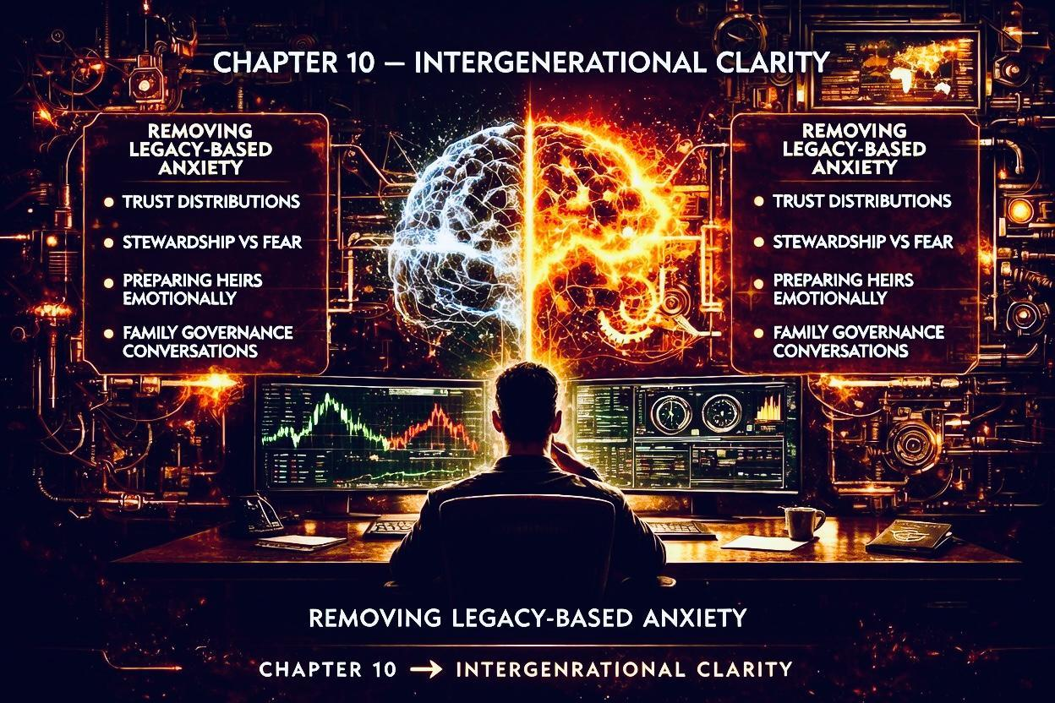
By now, you have mastered the inner machinery of calm, the Sentinel, architecture, strategic discretion, social immunity, and measured expansion.
But true financial sovereignty is not an endpoint in numbers alone. It is measured by how your capital, decisions, and protocols compound across time, stress, and societal influence, creating enduring value and freedom.
This chapter explores legacy through the lens of research, behavioral finance, and structured strategy, showing how disciplined frameworks produce long-term compounding of wealth and psychological resilience.

The Science of Financial Legacy
Research consistently demonstrates that wealth preservation is as much behavioral as numerical.
- Studies in behavioral portfolio theory (Shefrin & Statman, 2000) show that high-net-worth individuals often violate optimal allocation due to emotional triggers, social comparison, or perceived pressures.
- Sequence-of-returns risk (Bengen, 1994) highlights that early portfolio drawdowns can disproportionately affect long-term sustainability.
- Intergenerational wealth transfer studies (Pew Charitable Trusts, 2021) indicate that only structured, disciplined legacies survive beyond one generation, emphasizing architecture over ad hoc generosity.
The Sovereign integrates these insights: protocols, thresholds, and architecture protect both capital and cognitive bandwidth, ensuring legacy is not compromised by emotion or short-term volatility.

Capital as a Tool, Not a Master
Sovereigns view wealth instrumentally, echoing both academic and practical research:
- Leverage for Opportunity – Allocate resources where risk-adjusted asymmetry is favorable. Research on Kelly Criterion and expected utility theory demonstrates that disciplined allocation maximizes growth without overstretching risk.
- Shield for Stability – Psychological and structural buffers, like liquidity reserves and diversification, reduce stress and improve cognitive performance. Studies on cortisol and decision-making show that chronic financial anxiety reduces executive function and opportunity capture.
- Vehicle for Legacy – Structured philanthropy, trust frameworks, and multi-generational governance create compounding effects that outlive the individual, supported by research on family office structures and wealth governance.
Key Insight: Capital without structure is noise; structure without capital is inert. Sovereignty requires both.

Scaling Influence Without Losing Sovereignty
Once personal capital and protocols are mastered, the next frontier is impactful expansion:
- Mentorship and Knowledge Transfer: Sharing frameworks ensures behavioral stability in successors. Evidence from organizational behavior shows that codified processes reduce failure in high-stress environments.
- Strategic Philanthropy: Structured giving aligned with long-term vision produces multiplier effects. Charitable impact studies reveal that deliberate, goal-oriented funding consistently outperforms ad hoc giving.
- Institutional or Venture Influence: Deploying capital and governance in ventures can amplify optionality, a principle supported by research in venture portfolio design, risk-adjusted returns, and scaling methodologies.
Sovereign Principle: Expansion is measured not just in monetary terms, but in the compounding of impact, stability, and influence.

Behavioral Anchoring: Identity and Decision Security
Research in behavioral finance underscores the danger of identity fusion with outcomes:
- Kahneman & Tversky (1979) demonstrated loss aversion, showing that emotional over-attachment to outcomes distorts risk assessment.
- Studies on financial stress show that decision fatigue and social comparison reduce portfolio efficiency.
Sovereigns anchor decisions in identity-independent frameworks:
- Self-worth is decoupled from portfolio value.
- Decisions are validated against pre-defined thresholds and protocols, not peer performance or emotion.
- Reflection and feedback loops reinforce calm, preserving cognitive bandwidth for opportunity recognition.

Compounding Calm: The True Multiplier
Long-term research in behavioral economics and portfolio theory confirms:
- Consistent, disciplined application of frameworks compounds more effectively than high-variance opportunistic trading.
- Volatility management, sequence-of-returns protection, and threshold adherence enhance probability of achieving long-term objectives.
- Psychological calm allows high-frequency operators to identify asymmetric opportunities without succumbing to emotion-driven mistakes.
Sovereigns compound not only capital, but trust in their own judgment, freedom from reactive stress, and influence across networks.

Practical Exercise: Codifying Your Sovereignty
- Compile your Sovereign Protocols – thresholds, expansion frameworks, Sentinel calibration, and daily practice.
- Map Multi-Generational Architecture – stability layers, discretionary growth layers, and optionality for successors or ventures.
- Simulate Long-Term Stress Scenarios – market drawdowns, sequence-of-returns challenges, social amplification events.
- Document Reflection Loops – record decisions, emotional triggers, and threshold breaches for continuous learning.
- Integrate Legacy Planning – trusts, structured philanthropy, mentorship, and governance frameworks.
The exercise ensures that knowledge, structure, and calm are embedded alongside capital, making your sovereignty resilient to both market and social pressures.

Closing Principle
Financial mastery is not only about wealth accumulation. It is about:
- Preserving and expanding capital with discipline
- Maintaining cognitive sovereignty under stress
- Cultivating influence and legacy that endures
Markets will fluctuate, peers will compare, volatility will spike, and red numbers will expand. But the Sovereign acts from protocol, composure, and identity-independent decision-making.
You are not simply building a portfolio.
You are architecting a life, a legacy, and a system that compounds beyond time, emotion, and circumstance.

Chapter 11

Automation Without Abdication: Using Systems Without Losing Authority
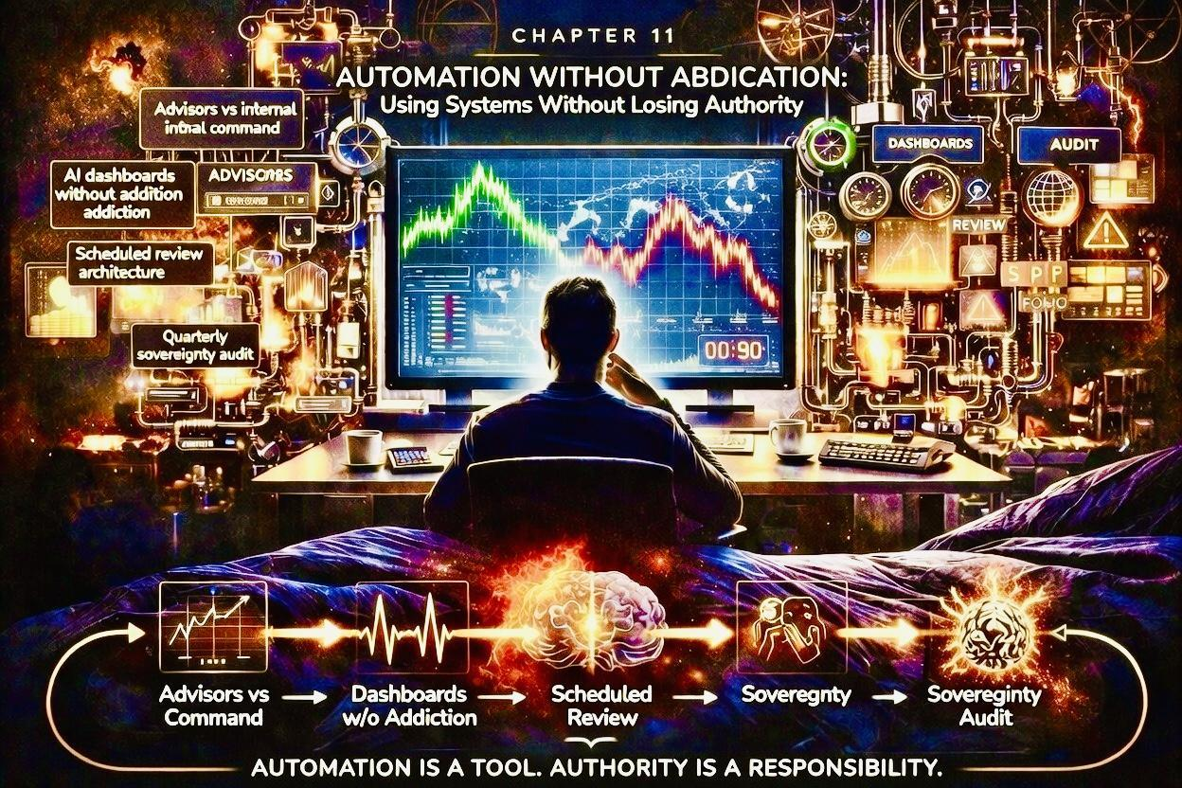
By now, you have mastered personal sovereignty, protocol discipline, expansion without anxiety, and social comparison immunity. The final frontier is automation — deploying systems, advisors, and AI dashboards to scale effectiveness without surrendering decision authority.
This chapter provides a research-informed framework for using automation as a force multiplier, ensuring that your control remains intact while capital, time, and information flow efficiently.

Advisors vs Internal Command
High-functioning investors increasingly rely on external expertise: wealth managers, portfolio analysts, tax specialists, and legal advisors. The key challenge: delegation without abdication.
Principles:
- Define the Decision Boundary
  - Determine which decisions are internal and non-delegable, and which can be informed by advisors.
  - Research in behavioral finance shows that over-delegation often leads to moral hazard and erodes internal confidence (Shleifer & Vishny, 1997).
- Protocol Alignment
  - Advisors execute within your Strategic Discretion thresholds.
  - All advice is filtered through pre-approved decision frameworks, preventing reactive emotional influence.
- Feedback Loops
  - Schedule structured review sessions.
  - Document deviations from advice and protocol to continuously calibrate both systems and human agents.
Outcome: Advisors amplify efficiency while sovereignty remains intact. The operator retains authority while leveraging expertise.

AI Dashboards Without Addiction
AI and automation tools are powerful but can become psychological traps if used compulsively:
- Continuous real-time monitoring can amplify the Sentinel, increasing anxiety rather than reducing it.
- Algorithmic alerts may trigger overreaction or false signals.
Sovereign Implementation Principles:
- Scheduled Viewing Windows
  - Limit AI dashboard interaction to daily or weekly protocol windows.
  - Treat alerts as data inputs, not commands.
- Signal Prioritization
  - Configure AI to flag only threshold breaches or significant deviations.
  - Avoid noise from minor fluctuations or irrelevant metrics.
- Decision Integration
  - AI provides insights. You decide.
  - Maintain mental sovereignty; AI augments, it does not replace judgment.
Research in decision automation shows that over-reliance on AI without human thresholds increases cognitive stress and can degrade judgment (Brynjolfsson & McAfee, 2017). The Sovereign avoids this trap by balancing automation with internal command.

Scheduled Review Architecture
Automation works best when paired with rigorous review structures.
Components:
- Daily Micro-Checks – Confirm that exposures remain within thresholds.
- Weekly Strategic Review – Assess the performance of new allocations, expansion strategies, and Sentinel signals.
- Monthly Reflection – Document deviations, lessons, and behavioral observations.
- Quarterly Audit – A comprehensive review integrating advisors’ insights, AI dashboards, and personal protocols (see next section).
Benefit: This architecture prevents overreaction, reduces cognitive fatigue, and reinforces disciplined sovereignty.

Quarterly Sovereignty Audit
The Quarterly Sovereignty Audit (QSA) is the ultimate check: a structured, research-backed evaluation of systems, capital, and personal decision-making integrity.
Key Steps:
- Protocol Compliance
  - Review all protocol adherence, threshold breaches, and Sentinel interventions.
- Advisor Alignment
  - Confirm all delegated actions complied with your decision boundaries.
- AI and Automation Effectiveness
  - Evaluate AI dashboards, alerts, and analytics. Remove unnecessary triggers and optimize signal clarity.
- Psychological Sovereignty Check
  - Self-assess anxiety levels, social comparison susceptibility, and reaction to market events.
  - Compare to prior quarters to monitor improvement or protocol drift.
- Strategic Adjustments
  - Update thresholds, allocation rules, and automation settings.
  - Adjust daily, weekly, or monthly routines based on findings.
Outcome: The QSA ensures that automation enhances capability without ceding authority. Sovereignty remains the constant, while systems scale effectiveness.

Integration With Overall Sovereign Architecture
Automation is the final amplifier of your existing frameworks:
- Daily Sovereign Protocol: Integrated with automated alerts to monitor thresholds.
- Expansion Gate: AI simulations assist with stress-testing new allocations.
- Social Comparison Immunity: Dashboards are filtered to minimize peer noise.
- Legacy Planning: Systems track long-term objectives and multi-generational protocols.
When used correctly, automation allows the Sovereign to operate at scale, maintain calm, and extend influence, without compromising mental or financial sovereignty.

Practical Exercise: Implementing Automation Without Abdication
- Map all advisors and systems – categorize into: advisory, operational, analytical.
- Define decision boundaries – explicitly mark which decisions are internal vs. delegated.
- Schedule review windows – daily, weekly, monthly, quarterly.
- Audit automation effectiveness – ensure AI signals are actionable and aligned with Strategic Discretion.
- Conduct Quarterly Sovereignty Audit – integrate insights, adjust thresholds, and reaffirm control.
Result: Automation becomes a force multiplier, not a dependency, ensuring that you remain the operator at all times.

Closing Principle
Automation, AI, and advisory networks are tools, not masters. Sovereignty is habit, protocol, and threshold discipline.
- Delegate operational load, not decision authority.
- Use AI as a signal amplifier, not a command engine.
- Audit regularly to ensure protocols, thresholds, and mental sovereignty are intact.
Automation without abdication is the final layer of Sovereign Financial Mastery. It ensures that your mind, capital, and legacy compound efficiently while remaining fully under your authority.

Chapter 12

The 30-Day Sovereign Reset: An Integration Blueprint

By Chapter 12, the reader has built:
- Calm in volatility
- Sentinel mastery
- Strategic Discretion
- Social comparison immunity
- Structured expansion
- Legacy frameworks
- Automation without abdication
All the principles are in place—but true sovereignty requires integration. Knowledge alone does not transform behavior; it must be practiced, measured, and internalized.
The 30-Day Sovereign Reset provides a research-backed, step-by-step framework for embedding your mastery into daily life, strengthening psychological resilience, and establishing enduring discipline.

Step-by-Step Daily Plan
Research in habit formation (Duhigg, 2012; Lally et al., 2010) shows that daily repetition with measurable outcomes is critical for internalizing new behaviors.
The Reset divides each day into four core modules:
- Morning Alignment (10–15 minutes)
  - Review Strategic Discretion thresholds and Sentinel calibration.
  - Set intentions for the day’s exposure, risk management, and interactions.
  - Optional: quick visualization of long-term objectives to prime focus.
- Midday Micro-Check (5–10 minutes)
  - Observe portfolio metrics and automated alerts.
  - Log any deviations or emotional reactions without acting impulsively.
  - Reinforce calm observation over reactive behavior.
- Evening Reflection (15–20 minutes)
  - Record actions taken, adherence to protocols, and Sentinel responses.
  - Assess deviations from thresholds and identify triggers.
  - Use a rating system (1–10) for anxiety, focus, and composure.
- Optional Integration Activity
  - Reading, journaling, or strategic thinking session aligned with growth or legacy objectives.
  - Reinforces cognitive sovereignty and long-term perspective.
Outcome: By following the plan, the mind and behavior are systematically aligned with financial and psychological protocols.

Anxiety Reduction Tracking
Persistent anxiety undermines decision quality and long-term capital growth. Quantifying and tracking it is essential:
- Daily Rating – Rate anxiety before and after micro-checks.
- Trigger Identification – Record events, news, or social cues that spiked tension.
- Response Evaluation – Note whether actions were protocol-compliant or reactive.
- Trend Analysis – Compare daily ratings over weeks to assess improvement.
Evidence: Research in cognitive behavioral therapy and behavioral finance shows that structured tracking reduces anticipatory anxiety, strengthens emotional regulation, and improves risk-adjusted decision-making (Beck, 2011).

Measuring Physiological Change
The Reset also emphasizes objective, bodily indicators of calm and stress management:
- Heart rate variability (HRV) to gauge stress response
- Sleep quality and duration
- Cortisol or other stress biomarkers (optional)
- Subjective energy and focus ratings
Principle: Financial mastery is not just cerebral. Physical regulation reinforces mental sovereignty, ensuring that the Sentinel remains a signal, not a source of anxiety.
Example: If HRV improves while anxiety ratings drop, the Reset is producing tangible physiological resilience alongside cognitive mastery.

Long-Term Discipline
A 30-day Reset is not a cure—it is a foundation for sustained practice. The goal is habitual sovereignty, where protocol adherence, reflection, and threshold discipline become automatic.
Strategies for Longevity:
- Gradual Expansion – After 30 days, incrementally increase exposure, complexity, or optionality layers.
- Monthly Review – Track Sentinel signals, deviations, and physiological metrics.
- Quarterly Sovereignty Audit – Reassess advisors, automation, and protocols (Chapter 11).
- Annual Reset – Reinforce the habit cycle with updated thresholds and behavioral insights.
Evidence: Research on habit stacking and neuroplasticity (Lally et al., 2010) confirms that consistent practice over 30–60 days produces durable neural changes, anchoring new behaviors into subconscious patterns.

Example Day in the Sovereign Reset
- 6:30 AM: Morning Alignment – review thresholds, visualize long-term objectives.
- 9:30 AM: Portfolio micro-check – log Sentinel reading; observe AI alerts without immediate reaction.
- 12:30 PM: Lunch reflection – short journaling, noting emotional responses to news, peers, or market signals.
- 5:00 PM: Evening Reflection – document adherence to protocols, review deviations, track anxiety rating.
- 7:00 PM: Integration session – read research, update strategic notes, plan next day.
After 30 days, patterns emerge: reduced emotional reactivity, improved focus, more confident decision-making, and measurable physiological resilience.

Closing Principle
The 30-Day Sovereign Reset is the bridge between theory and enduring practice. It integrates:
- Financial architecture
- Sentinel control
- Protocol discipline
- Social comparison immunity
- Expansion and automation frameworks
By the end of the Reset, the reader has internalized a repeatable, measurable, and scalable system for:
- Reducing anxiety
- Enhancing composure
- Strengthening decision sovereignty
- Measuring tangible improvements in cognition and physiology.
________________________Bonus Section The Sovereign Financial Audit
The Sovereign Financial Audit is the final layer of your mastery framework. It transforms the principles, protocols, and resets outlined in this book into tangible, actionable tools. These downloadable and printable resources allow you to measure, track, and refine your financial and psychological sovereignty over time.

1. Anxiety Baseline Sheet
Purpose: Quantify your starting point so you can track improvement over time.
Components:
- Daily Anxiety Rating (1–10): Before and after market interaction or Sentinel activation.
- Trigger Identification: Record events, market news, social comparisons, or internal reflections that provoke stress.
- Sentinel Signal Assessment: Note whether the response was protocol-driven or reactive.
- Trend Tracking: Graph weekly averages to visualize reduction in baseline anxiety.
Usage: Complete at the beginning and end of each day during the 30-Day Sovereign Reset. Over time, the baseline should decrease, reflecting improved emotional control and cognitive sovereignty.

2. Strategic Discretion Calculator
Purpose: Provide a quantifiable framework for decision thresholds, ensuring calm and measured action in complex financial environments.
Components:
- Portfolio Exposure Limits: Maximum allowable allocation per asset class or strategy.
- Risk Tolerance Index: Combine financial, psychological, and time-horizon factors to determine discretionary leeway.
- Action Trigger Thresholds: Identify signals that require active engagement versus passive observation.
- Decision Confidence Score: A calculated metric ensuring that every choice aligns with your long-term architecture.
Usage: Before any significant allocation, expansion, or strategic move, calculate your Strategic Discretion score. Decisions outside this threshold are deferred, automated, or escalated to your protocol-defined review.

3. Decision Review Journal
Purpose: Reflect, learn, and refine the internal processes of financial sovereignty.
Components:
- Decision Log: Record the decision, rationale, and outcome.
- Protocol Compliance Check: Was the decision aligned with Strategic Discretion and Sentinel calibration?
- Emotional Assessment: Track anxiety, excitement, or impulsivity levels during execution.
- Lessons Learned: Note patterns, errors, or insights for behavioral adaptation.
Usage: Fill this out daily or weekly. Over time, this journal becomes a behavioral blueprint for disciplined decision-making, reducing overreactions and reinforcing confidence in your protocols.

4. Quarterly Sovereignty Checklist
Purpose: A structured evaluation of your entire financial and psychological architecture to maintain long-term mastery.
Components:
- Protocol Adherence Review: Confirm daily, weekly, and monthly protocols were executed.
- Advisor and Automation Assessment: Check compliance with decision boundaries, AI dashboard effectiveness, and delegation frameworks.
- Sentinel & Anxiety Metrics: Review trend data from Anxiety Baseline Sheets and physiological measurements.
- Expansion & Exposure Review: Evaluate growth strategies against Strategic Discretion thresholds.
- Legacy & Optionality Assessment: Confirm progress toward multi-generational structures, philanthropic goals, and personal influence.
- Action Items & Adjustments: Document required protocol updates, threshold recalibrations, or behavior changes.
Usage: Conducted quarterly, this checklist ensures that sovereignty is actively maintained, avoiding drift, overextension, or unconscious reactivity.

Implementation Guidance
- Download and print the four tools.
- Integrate them with your 30-Day Sovereign Reset and ongoing protocols.
- Maintain a physical or digital archive to track progress over months and years.
- Use the insights to refine protocols, expand Strategic Discretion, and strengthen mental sovereignty.

Closing Principle
These tools convert abstract concepts into actionable, repeatable practice. Financial mastery and psychological sovereignty are not static—they are continuously measured, iterated, and improved.
Mastery is achieved not The Sovereign Financial Audit ensures that you operate with calm, act with authority, and grow with clarity, keeping your capital, mind, and legacy aligned with enduring sovereignty.
___________________________

Final Thoughts
You have now journeyed through the complete framework of Sovereign Financial Mastery: from mastering the Sentinel, establishing Strategic Discretion, building social comparison immunity, to scaling capital calmly, automating without abdication, and integrating your protocols into daily life with the 30-Day Sovereign Reset.
This work is not just a guide to managing wealth—it is a blueprint for living with composure, clarity, and authority, no matter the volatility of markets, peers, or circumstances. The principles you have practiced here are designed to compound over time, strengthening not only your portfolio but your confidence, decision-making, and long-term legacy.

Gratitude to the Reader
I want to sincerely thank you for committing the time, attention, and effort required to absorb these concepts and implement the practices outlined in this book. Your pursuit of financial and psychological sovereignty is the same mindset that has allowed so many high-performing individuals to thrive in turbulent times.
Your journey does not end here. Sovereignty is a practice, a habit, and a continuous pursuit. I hope the tools, protocols, and insights in this book serve as a daily companion as you refine your mastery, scale your capital, and protect your legacy.

Request for Review
If this book has provided value to you, I would deeply appreciate it if you could leave a review on the platform where you obtained it. Reviews help other readers discover these frameworks and allow me to continue creating work that is actionable, research-backed, and empowering. Your feedback is both valued and vital to the Sovereign community.

Suggested Further Reading
To continue deepening your understanding of financial architecture, behavioral mastery, and market dynamics, I invite you to explore my previous works:
- Bubble Logic – Understanding market cycles and structural overvaluation.
- The Crowd 2.0 – Navigating social influence and herd behavior in investing.
- The Sovereign Man Protocol – Building personal and financial sovereignty in an era of uncertainty.
Each of these titles complements the frameworks presented here, offering additional strategic insight, real-world examples, and actionable systems to expand your mastery.

Thank you for choosing to invest your time and attention in mastering not only your finances, but your mind, your decisions, and your legacy. May you continue to operate with calm, clarity, and authority, always sovereign.

Sovereignty is built, not declared. The Reset converts knowledge into lived mastery, creating a mind and life aligned with calm, clarity, and enduring influence.

